INTOSAI-DONOR SECRETARIAT
NARRATIVE PROGRESS REPORT 2012
FINAL REPORT 2010-12
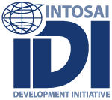

INTOSAI-DONOR COOPERATION

29 AUGUST 2013

TABLE OF CONTENTS
ANNEXES 2
ACRONYMS 3
EXECUTIVE SUMMARY 4
1. INTRODUCTION 7
1.1 Report Purpose 7
1.2 INTOSAI-Donor Cooperation Background 7
1.3 Results Framework for Reporting 7
1.4 Support for the INTOSAI Donor Secretariat 11
2. Report on Phase 1 Overall Results and 2012 Progress 13
2.1 Levels of Results Reporting 13
2.2 Reporting Against the Overall Objective: Has Performance of SAIs in Developing Countries Improved? 14
2.3 Reporting Against the Project Purpose: has the INTOSAI-Donor Cooperation Improved the Effectiveness and Increased the Volume of Capacity Development Support to SAIs in Developing Countries? 21
2.4 Reporting against the 2012 Work Program 24
3. Financing 32
3.1 Overall Financial Position, 2010-12 32
3.2 Budget Execution, 2012 33
3.3 Budget Execution, 2010-12 35
4. EXPLANATION OF MAJOR DEVIATIONS 36
5. ASSESSMENT OF PROBLEMS AND RISKS 36

ANNEXES
Annex A: Signed English Financial Statements for IDI 2012
Annex B: English notes to Financial Statements for IDI 2012
Annex C: Signed Norwegian Auditors Report for IDI 2012 and translated English Auditors Report 2012
Annex D: Signed English IDI Annual Board Report 2012
Annex E: Annual IDI Progress Report 2012

ACRONYMS
CBC Capacity Building Committee
Cooperation INTOSAI-Donor Cooperation
Database SAI Capacity Development database
DFID UK Department for International Development
EITI Extractive Industries Transparency Initiative
GCP Global Call for Proposals
IDI INTOSAI Development Initiative
ISSAIs International Standards of Supreme Audit Institutions
INTOSAI International Organization of Supreme Audit Institutions
MoU INTOSAI-Donor Memorandum of Understanding
OAGN Office of the Auditor General of Norway
PEFA Public Expenditure and Financial Accountability
PMF Performance Measurement Framework
ToRs Terms of Reference
SAI Supreme Audit Institution
SAI CDF SAI Capacity Development Fund
SC INTOSAI-Donor Steering Committee
Secretariat INTOSAI-Donor Secretariat
WB The World Bank
WGVBS Working Group on the Value and Benefits of SAIs

EXECUTIVE SUMMARY
The Memorandum of Understanding (MoU) between INTOSAI and the Donor community signed in 2009 established the INTOSAI-Donor Cooperation (Cooperation), which has since expanded from 15 to 20 donor members. The INTOSAI-Donor Steering Committee (SC) agreed to establish the INTOSAI-Donor Secretariat (Secretariat) based in the INTOSAI Development Initiative (IDI) in Oslo. The donor agencies of Austria, Ireland and Norway agreed to provide financial support to the Secretariat from June 2010 to December 2012. In addition, in-kind staff support was provided by the Supreme Audit Institution (SAI) of Norway. This report summarizes the achievements of the Cooperation, and specifically accounts for the use of funds by the Secretariat.
The overall objective of the INTOSAI-Donor Cooperation is to strengthen public sector auditing in partner countries, with the project purpose being defined as improving the effectiveness and increasing the volume of capacity development support to SAIs in partner countries. The Cooperation sets annual work plans to contribute to this objective and purpose; however achievement of the purpose depends on change within many donor agencies and SAIs. Achievement of the objective requires sustainable changes in the performance and capacities of SAIs, which is a long term change dependent on many factors beyond the control of the Cooperation. Considering this, we report on achievements and progress at the levels of objective, purpose, and work plans.
- Overall objective: has performance of SAIs in developing countries improved? (Section 2.2)
Project Contract Indicator 1: | PEFA and other diagnostics shows improvement in external audit capacity in partner countries | Progress: Met
Project Contract Indicator 2: | Stocktaking in 2010 and 2012 demonstrates increases in average audit coverage | Progress: Met
Project Contract Indicator 3: | Stocktaking in 2010 and 2012 shows improvements in average timeliness of annual reports | Progress: Met
Analysis of PEFA data shows an improvement in SAI performance between May 2010 and April 2012, both globally and within all income groups. The percentage of SAIs scoring a C+ or higher on PEFA PI-26 increased from 38% to 44%. Examination of 50 countries with repeat PEFA assessments shows that over the period 2005-12, the broad direction of change on audit coverage and timeliness of audit reports is positive. However it is noted that the performance of external audit has declined in a small number of countries. Examining SAI performance at the country level, based on 22 published repeat PEFA assessments, shows positive results in English speaking Africa and Europe, mixed results in French speaking Africa and the Pacific, and positive results in other regions for which data exists. It is notable that the amount of data, and variety of data sources on SAI performance, is very limited. A number of ongoing initiatives are designed to improve the quantity and quality of data on global SAI performance.
- Project purpose: has the Cooperation improved the effectiveness and increased the volume of support to SAIs in developing countries? (Section 2.3)
Project Contract Indicator 4: | Stocktaking in 2010 and 2012 shows that higher proportion of capacity development support is based on needs identified in SAI Strategic and Development Action Plans. | Progress: positive progress
Project Contract Indicator 5: | Stocktaking in 2010 and 2012 show that SAIs in partner countries on average are recipients of fewer but bigger and more long-term capacity development support programmes. | Progress: no data – awaiting IDI Global Survey 2013
Project Contract Indicator 6: | Evaluations of projects under the auspices of the SC demonstrate increased utilization of identified good practices and harmonization of the manner in which support is provided. | Progress: to early to assess
Based on the 2010 stocktaking, in the first round of project matching the Cooperation prioritised support to development of SAI strategies in regions were these were weak. The 2011 Global Call for Proposals (GCP) sought to ensure that more support to SAIs was based on SAI owned strategies. During 2010-12, new projects were identified and launched, and global surveys and evaluations are planned for 2013 and 2014. It is therefore too early to assess the impact of the Cooperation on the effectiveness of support. However, anecdotal evidence shows initiatives such as the GCP and SAI Capacity Development Database (Database) are contributing to better donor harmonization of support in some countries, with duplication of projects being reduced. Finally, forecast figures from the Database suggest the volume of global of support to SAIs is increasing, from USD 41 million per annum over 2010-12 to USD 56 million per annum 2012-14.

- Annual work plans set by the SC. (Section 2.4 and annual progress reports)
The Secretariat has been tasked with, and reported on, implementation of annual work plans for 2010, 2011 and 2012. Progress against priority activities during 2010-12 is summarized below.
Stocktaking of the SAI community. In 2010 the first ever global stocktaking of the INTOSAI Community was carried out with a response rate of above 90% of the 190 INTOSAI members. It identified a clear need to scale up the levels, and improve coordination, of support to SAIs in developing countries.
Matching of regional and global high priority needs. Based on the stocktaking, eight priority global and regional capacity development initiatives were matched with providers of support, including: the global ISSAI Implementation Initiative (3i program); roll-out of the INTOSAI Capacity Building Guides; development of strategic plans for CAROSAI and CREFIAF; two strategic planning programs for 14 SAIs in CREFIAF; and a management development program for SAIs in AFROSAI-E.
SAI Capacity Development Database www.SAIdevelopment.org. The Database was launched in 2012 and contains information on support provided by SAIs, donors and private sector service providers. It comprises more than 240 capacity development projects, and is now actively used by providers of support to coordinate and plan their capacity development efforts.
Global Call for Proposals. In 2011 a Global Call for Proposals was launched to identify and support demand-led SAI capacity development initiatives. Providers of support expressed indicative interest in supporting 44 of the 55 proposals, and a number of these have already been turned into action. These include developing performance auditing in CREFIAF; strengthening the organizational capacity of ARABOSAI and enhancing the training capacity of its members; and SAI level initiatives in countries such as Argentina, Bhutan, Macedonia, and Uganda. Recognizing the need to strengthen the capacity of SAIs to write applications that reflect identified capacity development needs and utilize robust results frameworks, a workshop was conducted for 19 SAIs in CREFIAF.
SAI Capacity Development Fund (SAI CDF). A Multi-Donor Trust Fund has been designed to scale up support, improve allocative efficiency, and reduce transaction costs for SAIs and donors. To date only Switzerland has committed funds and at least one additional donor is required to establish the SAI CDF.
Performance Measurement Framework for Supreme Audit Institutions (SAI PMF). The INTOSAI Congress 2010 mandated the development of a tool to measure the performance of SAIs. The SAI PMF is a standardized framework with objective indicators and a qualitative performance report to give a holistic, high level assessment of SAI performance against established INTOSAI good practices. It enables measurement of performance over time. The Secretariat is coordinating the Task Team established to develop the Framework. During 2011-12, the Task Team successfully completed a mapping of existing assessment tools, produced a concept note which was endorsed by the INTOSAI Working Group on the Value and Benefits of SAIs (WGVBS), published draft version 2.0, piloted it in Norway, Sierra Leone and Djibouti, and conducted a global consultation on the framework.
This first phase has successfully established the Cooperation’s governance arrangements and position in the international Public Financial Management architecture. Successful matching of high priority global and regional initiatives with interested donors helped build mutual trust and momentum for further cooperation. New coordinated global initiatives, such as the Database and the GCP, are helping to strengthen the way support is provided to SAIs, following principles of SAI ownership, alignment and harmonisation. The SAI Performance Measurement Framework (PMF) will better enable a results focus in SAI capacity development support, and sets the ground for future research and evidence based policy making. This will be supported by the IDI global survey: a survey into SAI performance and capacity to be carried out every three years by IDI. More SAIs are expanding peer to peer support and examining ways of making such support more effective, and donors are increasingly recognising the role of Supreme Audit Institutions in building effective states.
With the Cooperation firmly established, a program document for 2013-15 was agreed by the SC in October 2012, funded by the donors of Austria, Ireland, Norway, Switzerland and the UK. The SAIs of Norway and Brazil are providing in-kind staff support, while others such as the World Bank and USAID are financing specific activities. We look forward to continuing support and cooperation between the INTOSAI and Donor communities, to work together to strengthen SAIs in developing countries.

INTRODUCTION

Report Purpose
Austria, Ireland and Norway have provided financing for the establishment and operation of the INTOSAI-Donor Secretariat (Secretariat) to support the INTOSAI-Donor Cooperation (Cooperation) in its first phase, June 2010 to December 2012. This report serves two purposes. Firstly, to report on progress of the Cooperation during 2012. Secondly, to act as a final report covering the 31 months of phase 1 of support to the Cooperation.
While phase 1 has been completed, work to strengthen Supreme Audit Institutions (SAIs) in developing countries continues. A program document for phase 2 of the Cooperation, 2013-2015, has been approved by the Steering Committee (SC) and financing has been obtained. Austria, Ireland and Norway have all provided core funding for phase 2, and the SAIs of Norway and Brazil are providing in-kind staff support. The World Bank is also providing support to specific themes within the program document.

INTOSAI-Donor Cooperation Background
Recognizing the importance of well functioning, multidisciplinary and independent SAIs, and that progress with donor support to SAIs so far has been varied, in October 2009 the International Organization of Supreme Audit Institutions (INTOSAI) and 15 Donors signed a landmark Memorandum of Understanding (MOU) to augment and strengthen support to SAIs in developing countries. During 2011 and 2012, a further five donor organizations signed the MoU. The MoU establishes the governance structure of the Cooperation, consisting of the SC as the decision making body, assisted by the Secretariat that provides administrative support. The inaugural SC Meeting decided to locate the Secretariat as an integral part of the INTOSAI Development Initiative (IDI) in Oslo, Norway. The Secretariat was established in April 2010 with financial support from Austria, Ireland and Norway. In 2012, the Secretariat establishment was between 3,5-4,5 positions. These positions were financed through the budget for the Secretariat, except for one position financed by the Office of the Auditor General of Norway (OAGN) through a rotational secondment arrangement where one member of staff will be on annual secondment to the Secretariat.

Results Framework for Reporting
As the tasks of the Secretariat evolve, and as the roles and responsibilities of the Secretariat depend on the work programs set by the SC, the Annual Donor Meeting in 2011 agreed that annual progress reporting should reflect the annual work program for the Cooperation adopted at the relevant SC meeting. The 2011 annual progress report was against the 2011 work program, and likewise this 2012 annual progress report includes reporting against the 2012 work program, agreed by the SC at its fourth meeting in India in February 2012. The work programs for 2011 and 2012 therefore update the interim Terms of Reference (ToRs) for the Secretariat which was used as a basis for the 2010 reporting. In addition as a final report on the program 2010-12, this report includes a review against the overall objective, purpose and indicators in the original program document and financing agreement.
The 2012 work program was as follows:
No. | Task | Priority for 2012 | Responsibility | Deadline
1 | a) Update and b) administer the SAI Capacity Development Database | HIGH | a) All SC members  b) Secretariat | a) 31 March  b) Continuous
2 | Matching of initiatives submitted under the Global Call for Proposals and donors, hereunder: a) Donors and SAI providers to express concrete interest in proposals by 24 May, b) Summary to be circulated by the Secretariat by 31 May | HIGH | Secretariat | October 2012
3 | Establish SAI Capacity Development Fund | HIGH | Pooled Fund Task Force | October 2012
4 | SAI Performance Measurement Framework – 1st draft and commence pilots | HIGH | SAI PMF Task Team (Coordinator – Secretariat) | December 2012
5 | Develop program document and funding proposal for 2013-15, for Austria, Ireland and Norway | HIGH | Secretariat | October 2012
6 | Facilitate SC leadership and SC meetings | HIGH | Secretariat | Continuous
7 | Support CBC work on strengthening SAI supply side | MEDIUM | Secretariat | Autumn
8 | Awareness raising and communication activities targeting INTOSAI and Donors | MEDIUM | Secretariat | Continuous
9 | Building capacity of SAIs to develop funding proposals | MEDIUM | Regions with support from Secretariat | Initiated in 2012
10 | Acting as a knowledge centre and repository to enhance coordination of support to SAIs | MEDIUM | Secretariat | Continuous
11 | Review of funding levels of SAIs (possibly linked to future INTOSAI stock taking) | LOW | To be discussed with appropriate INTOSAI bodies | TBC
12 | Explore the question of SAI involvement in the audit of revenue from extractive industries and INTOSAI engagement with the Extractive Industries Transparency Initiative (EITI) | LOW | Secretariat to coordinate with INTOSAI bodies, OAG Norway, EITI, DFID, NORAD, IMF etc. | TBC
Adopted at the 4th INTOSAI-Donor Steering Committee Meeting, Jaipur, 25th February 2012
The Secretariat carries out the work program activities, with support of the Steering Committee.
Since 2011, the Secretariat has been driving forward initiatives to incorporate results based approaches throughout the INTOSAI community. It has developed a results framework for the INTOSAI-Donor Cooperation as a whole, depicted below, and a monitoring mechanism using a LOGFRAME approach incorporating indicators, baselines and targets for high-level outcomes, initial outcomes and outputs. These were approved and adopted by the SC at its fifth meeting in London in October 2012, as part of the INTOSAI-Donor Cooperation phase 2 (2013-15) program document.

The Secretariat is also coordinating an INTOSAI initiative to develop a performance measurement framework (PMF) for SAIs (a PEFA-style drill-down tool) which will enable better measuring and monitoring of SAI performance at country, regional and global levels in future. The baselines, results framework, monitoring mechanism, and SAI PMF will also enable better evaluation of SAI capacity development, and the contribution of donor support to SAI capacity development, in future.

The reporting for 2012 reflects the contributions of the INTOSAI-Donor Secretariat in reaching the outcomes and outputs for the INTOSAI-Donor Cooperation outlined in the results framework below. While this results framework in no ways contradicts the objectives, purposes and expected results outlined in the agreed project summary, included as annex 1 to the financing agreement, it is deemed to be more relevant as a reporting tool as it provides a more holistic framework for measuring and monitoring progress in scaling up and strengthening support to developing country SAIs. Nevertheless, the overall objective, purpose and indicators from the financing agreement have been incorporated into this final report.
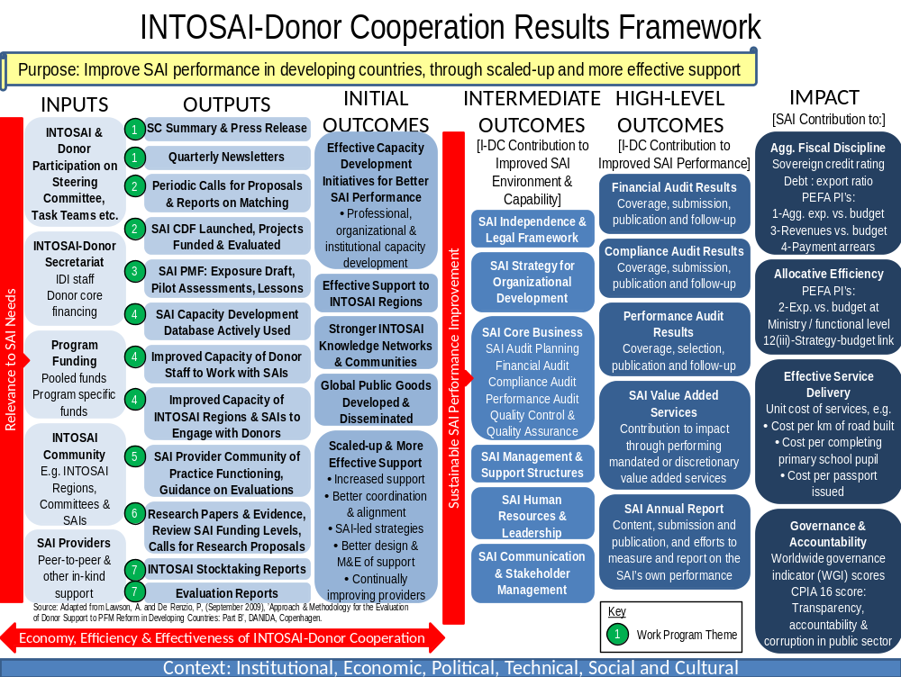
Note: ‘Work Program Theme’ relates to the seven themes agreed in the 2013-15 program document.

Support for the INTOSAI Donor Secretariat

Following the establishment of the Secretariat, the Norwegian Agency for Development Cooperation, the Austrian Development Cooperation, and Irish Aid expressed their willingness to provide support to the Secretariat for the period 01.06.2010-31.12.2012. The parties agreed on a project document titled “Funding of INTOSAI-Donor Secretariat 2010-2012” in October 2010 and signed a joint financing agreement/contract in November 2010. Under the joint financing agreement, the Austrian Development Agency committed themselves to providing a contribution of up to Euro 300 000, Irish Aid to provide a contribution up to Euro 200 000 and the Norwegian Agency for Development Cooperation to provide a contribution of up to NOK 8 400 000 for implementation of the project from the date of signature until December 2012.
In 2012 the Secretariat was staffed as follows:
Position | Title | Comments
0,5 | Head of Secretariat / Deputy Director General IDI | The head of the Secretariat works 50 % for the INTOSAI-Donor Secretariat and 50 % for the IDI as Deputy Director General for administration and stakeholder relations. 50 % of his salary costs are covered over the INTOSAI-Donor Secretariat budget.
1 | Advisor (International) | Salary costs covered over the INTOSAI-Donor Secretariat budget.
1 | Advisor (Norwegian) | Salary costs covered over the INTOSAI-Donor Secretariat budget.
1 | Advisor (international) (from October 2012) | Salary costs covered over the INTOSAI-Donor Secretariat budget.
1 | Advisor (OAGN secondee) | Salary costs covered by the Office of the Auditor General of Norway.
The total number of positions increased from 3,5 to 4,5, of which all but one position was financed from the Secretariat’s budget. The head of the Secretariat is also head of administration and stakeholder relations in the IDI and the salary is funded 50 % from the Secretariat’s funds and 50 % from core IDI funds. The dual responsibility enables exploitation of synergies and more effective coordination and information sharing between the INTOSAI-Donor Cooperation and the IDI program activities. The Office of the Auditor General of Norway offers a secondment in the Secretariat for one of their staff each year, and they cover the salary cost of the secondee.
In both 2011 and 2012, Ireland agreed to provide a further Euro 200 000 to the Secretariat in addition to the obligations under the joint financing agreement. Addenda were signed to this end.
The joint financing agreement also stipulates that there will be an Annual Donor Meeting in order to discuss progress on the project and the cooperation of the funding Donors. Wherever possible, the Annual Donor Meeting should be organized together with the regular SC Meetings. The 2011 Annual Donor meetings was held in connection with the third SC Meeting in Washington in July 2011 and the 2012 Annual Donor Meeting was held in India in connection with the fourth SC Meeting in February 2012. At the fifth SC meeting in London in October 2012, there was an additional, informal meeting with the Donors that were present.
Paragraph 6 and 7 of the Joint Financing Agreement outlines the reporting requirements, consisting of a narrative progress report, a signed version of the annual IDI financial statements and the annual IDI audit report. These documents are to be submitted to the Donors by 31 May each year. For this 2012 report, IDI requested an extension to 12 June 2013 on account of work program commitments, mainly SAI PMF development and training and work to secure additional funding for phase 2 of the Cooperation. This was duly granted by the Donors.
Paragraph 6.2 states that the narrative report shall include the following:
- An assessment of the progress of the implementation of the project as described in the Project Summary (Annex 1) and the mandate for extended secretarial functions made by the inaugural SC meeting in Marrakech 22-24 February 2010
- A detailed table including the use of funds compared to budget
- An explanation of major deviations from the annual plan
- An assessment of problems and risks that may affect the success of the future work plan
- An assessment of any need for adjustments to agreed plans and/or inputs and outputs, including actions for risk mitigation
Paragraph 6.2 states that:
- After completion of the project, a final report shall be submitted at the same time of the calendar year as for the previous narrative and financial reports.
The following constitutes the narrative progress report for 2012 and the final report, 2010-12. There are five annexes to the report, namely: Annex A: Signed English Financial Statements for IDI 2012 , Annex B: English notes to Financial Statements for IDI 2012 , Annex C: Signed Norwegian Auditors Report for IDI 2012 and translated English Auditors Report 2012, Annex D: Signed English IDI Annual Board Report 2012, and Annex E: Annual IDI Progress Report 2012

Report on Phase 1 Overall Results and 2012 Progress

Levels of Results Reporting
The overall objective of the INTOSAI-Donor Cooperation is to strengthen public sector auditing in partner countries, with the project purpose being defined as improving the effectiveness and increasing the volume of capacity development support to SAIs in partner countries. These are long term, high level objectives to which phase 1 and phase 2 of the INTOSAI-Donor Cooperation are designed to contribute. The end of phase 1 provides a suitable opportunity to report on progress towards these objectives, as well as progress against the 2012 work program.
Therefore reporting is at three levels:
  - Reporting against the overall objective (high-level outcomes in the above results framework): has performance of SAIs in developing countries improved?
  - Reporting against the project purpose (initial outcomes in the above results framework): has the INTOSAI-Donor Cooperation improved the effectiveness and increased the volume of capacity development support to SAIs in developing countries?
  - Reporting against the 2012 work plan (outputs in the above results framework): were the planned outputs of the INTOSAI-Donor Cooperation for 2012 achieved?
The possibility to report at these levels is dependent on the availability of suitable data. The project document envisaged the main data sources for reporting to be PEFA (and other diagnostics) data, INTOSAI global surveys, evaluations of completed projects, and documents produced by the Steering Committee and Secretariat. In the following, the latest PEFA data has been analyzed as the primary source for monitoring high level objectives. Since the original INTOSAI global survey in 2010, no further survey has been conducted. It was not prioritized in the 2012 work program, and the 2013 work program notes that a decision on a global survey should be taken during 2013, subject to progress in development of the INTOSAI Information Database. It is now expected that work on the next global survey will commence in the second half of 2013. There are therefore no further global survey results available to inform progress monitoring.
Similarly, few of the global, regional and country level projects that have been initiated as a result of the INTOSAI-Donor Cooperation have been completed; hence there is little evaluation evidence from these projects to date. In the phase 2 work program, a synthesis of SAI project evaluations is planned for 2014.
Other sources of information for progress monitoring include the SAI Capacity Development Database and documents produced by the Steering Committee and Secretariat. Along with the PEFA data, this is the main source for progress monitoring.

Reporting Against the Overall Objective: Has Performance of SAIs in Developing Countries Improved?
Project Contract Indicator 1: | PEFA and other diagnostics shows improvement in external audit capacity in partner countries | Progress: Met
SAI performance in developing countries continues its gradual improvement. This is evidenced below. The likely sources of these improvements are the combined efforts of the following:
- SAIs in developing countries
- Other domestic stakeholders including Parliaments and civil society groups
- The work of the INTOSAI community including its committees, task forces and working groups, as well as INTOSAI regional bodies and the IDI
- Bilateral support provided to SAIs by peer SAIs and donors
- Other international stakeholders, such as the UN, OECD, and international initiatives such as the PEFA program and the International Budget Partnership
The INTOSAI-Donor Cooperation plays a supporting role to try to improve the effectiveness of support provided to SAIs by all stakeholders. It is not possible to attribute the improvements in global SAI performance in developing countries to any of the above stakeholders including the INTOSAI-Donor Cooperation. Therefore this report makes no attempt to do so.
Analysis of Cross-Country PEFA Data at Points in Time
Comparing the latest available PEFA data (April 2012) to the PEFA data (May 2010) used in the 2010 INTOSAI Stocktaking demonstrates a global increase in levels of SAI performance. Specifically, it shows an increase in the proportion of countries scoring a C or higher on their latest PEFA indicator, meaning all the following conditions are in place in relation to the SAI:
- Central government entities representing at least 50% of total expenditure are audited annually
- Audits identify significant issues
- There is some disclosure regarding the nature of the audit standards used
- Audit reports are submitted to the legislature within 12 months of the end of the period covered (and for financial audits, within 12 months from receipt of financial statements by the SAI)
- A formal response is made (by the executive) to audit reports (though it may be delayed or not very thorough)

Indicator: Percentage of SAIs scoring a C or higher on PEFA PI-26 ‘Scope, nature and follow-up of external audit). | May 2010 PEFA Data | April 2012 PEFA Data | Increase (percentage points)
All developing countries | 38%  (n=87) | 44%  (n=117) | 6
Least Developed Countries and Other Low Income Countries | 26%  (n=35) | 34%  (n=47) | 8
Lower Middle Income Countries | 33%  (n=27) | 45%  (n=33) | 12
Upper Middle Income Countries | 60%  (n=25) | 54%  (n=37) | (6)
The performance increase is observed across developing countries as a whole, as well as within the group of least developed and other low income countries, and the group of lower middle income countries. Regarding upper middle income countries, the percentage of countries scoring a C or higher has declined from 60% to 54%. Closer examination reveals that in the April 2012 data, the additional 12 UMI countries in the population includes six small island states (the majority from the Caribbean), all of which score D or D+, as well as a further three countries entering the data for the first time, which all score D+. The decline in this indicator is therefore attributable to the change in the population, rather than to declines in performance within UMI countries. (Further evidence to support this is provided under ‘Global Analysis of Repeat PEFA Assessments’ below).
At both measurement points, there is a positive link between income levels and SAI performance, with wealthier country groups showing stronger performance. This is as expected and fits with findings from de Renzio, Andrews & Mills that “economic factors are the most important in explaining differences in the quality of PFM systems” . It also reminds us that the pace of SAI reform is likely to be bounded by the pace of economic development in a country.
Analysis of Distribution of PEFA Dimension Scores
PEFA PI-26 comprises the following three dimensions, each of which is scored on a scale from A to D:
- Dimension (i) Scope/nature of audit performed (including adherence to auditing standards)
- Dimension (ii) Timeliness of submission of audit reports to legislature
- Dimension (iii) Evidence of follow up on audit recommendations
Comparing the distribution of dimension scores between 2010 and 2012 illustrates changes in SAI performance, as shown in the following table.
Dimension | Year | Population (n) | % A | % B | % C | % D
(i) Scope/nature of audit performed (including adherence to auditing standards) | 2010 | 81 | 7 | 31 | 26 | 36
 | 2012 | 112 | 7 | 27 | 32 | 34
(ii) Timeliness of submission of audit reports to legislature | 2010 | 80 | 14 | 25 | 20 | 41
 | 2012 | 111 | 22 | 26 | 16 | 36
(iii) Evidence of follow up on audit recommendations | 2010 | 81 | 11 | 27 | 27 | 35
(iii) Evidence of follow up on audit recommendations | 2012 | 114 | 11 | 32 | 25 | 32

On dimension (i) the data shows a slight shift from B to C scores implying weaker global performance. This appears to be a combination of a small net improvement on this dimension within those countries undertaking a repeat assessment (for evidence, see analysis below), more than offset by the weaker performance of countries entering the data set for the first time (for evidence, see analysis above).
On dimension (ii), there appears to be a significant increase in the percentage of A scores, with little net change in B scores, and smaller proportions of C and D scores. Consistent with the analysis below, this shows performance improvements in the timely submission of reports to the legislature.
On dimension (iii), there is a slight increase in the percentage of B scores and a corresponding decrease in the percentage of C and D scores, suggesting a slight improvement in the follow up of audit recommendations.
Global Analysis of Repeat PEFA Assessments
Project Contract Indicator 2: | Stocktaking in 2010 and 2012 demonstrates increases in average audit coverage | Progress: Met  Evidenced by PEFA data
Project Contract Indicator 3: | Stocktaking in 2010 and 2012 shows improvements in average timeliness of annual reports | Progress: Met  Evidenced by PEFA data
Using the full PEFA data set (including unpublished results), containing assessment results from 2005-12, there are now 50 countries for which there has been a repeat PEFA assessment in which PI-26 has been scored. Analyzing the changes in the scores between the latest assessment and the previous assessment shows the following aggregate results. Note that the assessment points for individual countries are determined by when the PEFA assessment were performed in that country. Therefore these results show only the overall direction of change during 2005-12. Some changes will therefore relate entirely to the period 2005-10 prior to establishment of the Cooperation. Some changes relate to periods overlapping with the set up of the Cooperation (e.g. 2008-2012), and others may relate to periods since the Cooperation was set up (e.g. 2010-12).
PI-26 Scope, nature and follow-up of external audit | Number of measurements from repeat assessments (n) | Number of scores increasing | Number of scores decreasing | Net number of scores increasing | % scores increasing | % scores decreasing | % net scores increasing
Overall Score | 50 | 18 | 7 | 11 | 36 % | 14 % | 22 %
(i) Scope/nature of audit performed (incl. adherence to auditing standards). | 40 | 10 | 6 | 4 | 25 % | 15 % | 10 %
(ii) Timeliness of submission of audit reports to legislature. | 40 | 16 | 4 | 12 | 40 % | 10 % | 30 %
(iii) Evidence of follow up on audit recommendations. | 38 | 11 | 4 | 7 | 29 % | 11 % | 18 %

Overall, in 36% of countries PI-26 has improved, while it has declined in 14% of countries. Thus overall performance change is largely positive, but it is noted that performance of the external audit function has declined in a small number of countries.
Analysis at the dimension level shows similar overall results: more countries in which PEFA scores are improving than declining. The most progress has been made on the timeliness of submission of audit reports to the legislature (dimension (ii)), with 16 countries showing an improvement and only four showing a decline. Evidence of follow-up on recommendations (dimension (iii)) shows the next strongest increase, with 11 countries improving and four declining. It should be noted that this dimension combines factors under the SAI’s control with factors only under its indirect influence (e.g. how and when the executive responds to audit recommendations). The area with the weakest performance improvement is dimension (i). This dimension combines the most factors, from the percentage of central government entities audited to adherence to auditing standards, and requires the most significant changes (including to the SAI’s resources) for performance improvements to lead to a change in the indicator scores. In this case, 10 countries show a performance improvement and 6 countries show a decline.
Country Level Analysis of Repeat PEFA Assessments
For analysis at the country level, it is only possible to use assessment results that the Government of that country has agreed to publish. All such assessments now appear on the PEFA portal for analysis purposes. 22 countries have published repeat PEFA assessments in which PI-26 was applied. Grouping these results by regions yields the following graphs from the PEFA portal.
PEFA PI-26: Scope, nature and follow-up of external audit – AFROSAI-E
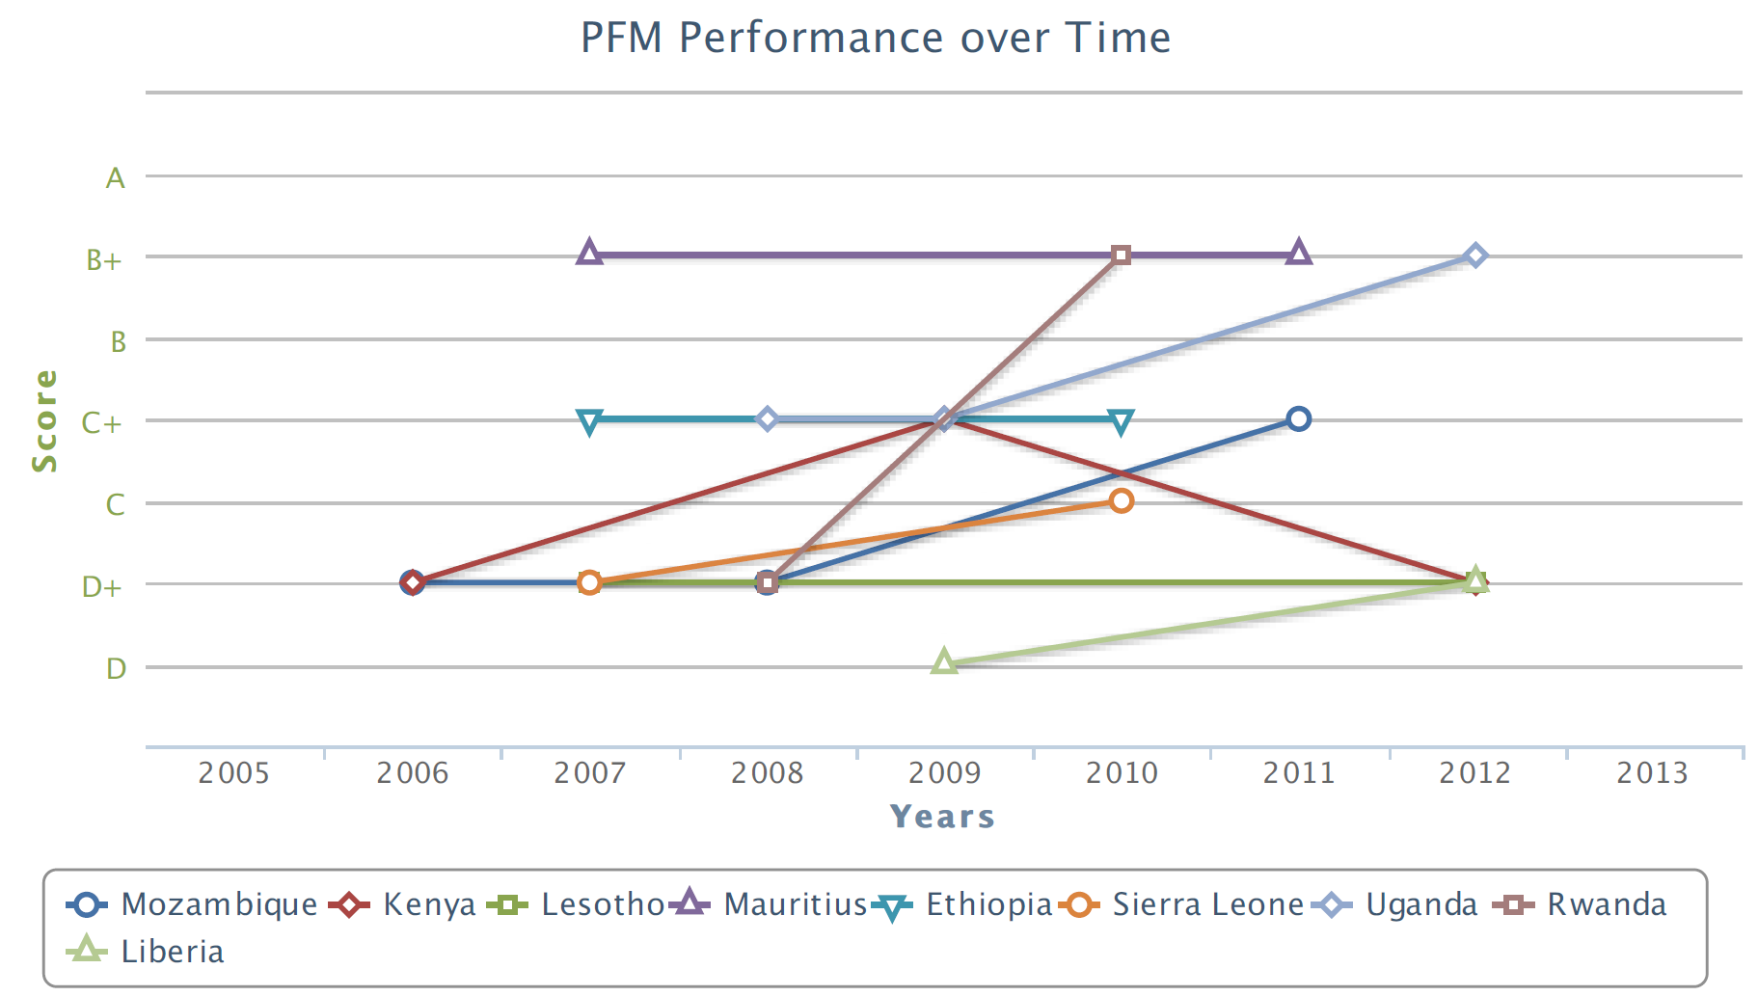
In AFROSAI-E, based on PI-26, there have been performance improvements in Liberia, Mozambique, Rwanda, Sierra Leone and Uganda. There has been no change in Ethiopia, Lesotho and Mauritius. Kenya first increased from a D+ to a C+, but returned to a C+ in its 2012 assessment, meaning no overall performance change.
PEFA PI-26: Scope, nature and follow-up of external audit – CREFIAF
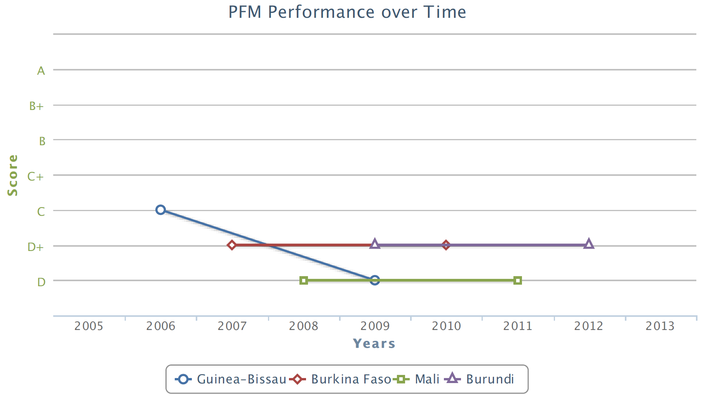
The picture in CREFIAF is less positive. In Guinea-Bissau, the score on PI-26 declined from C in 2006 to D in 2009, consistent with the worsening governance situation in the country. In Burkina Faso, Mali and Burundi there has been no change in the PEFA score for PI-26.
PEFA PI-26: Scope, nature and follow-up of external audit – Europe
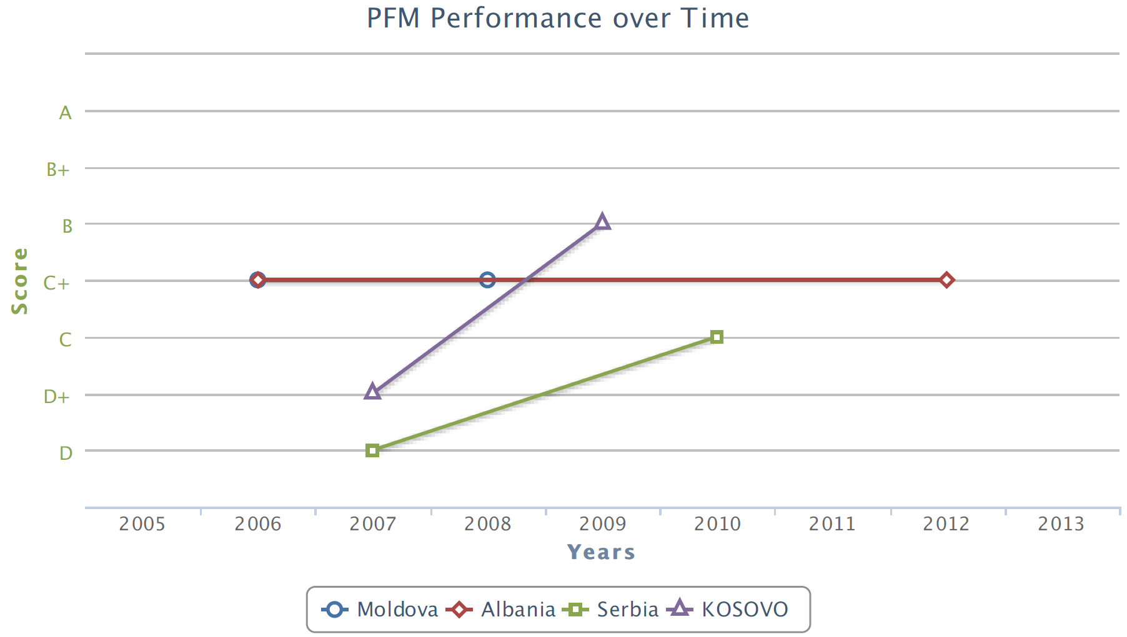
In developing countries in Europe, the very limited published PEFA data shows improvements in Serbia and Kosovo. It further shows no change in Moldova and Albania.
PEFA PI-26: Scope, nature and follow-up of external audit – PASAI
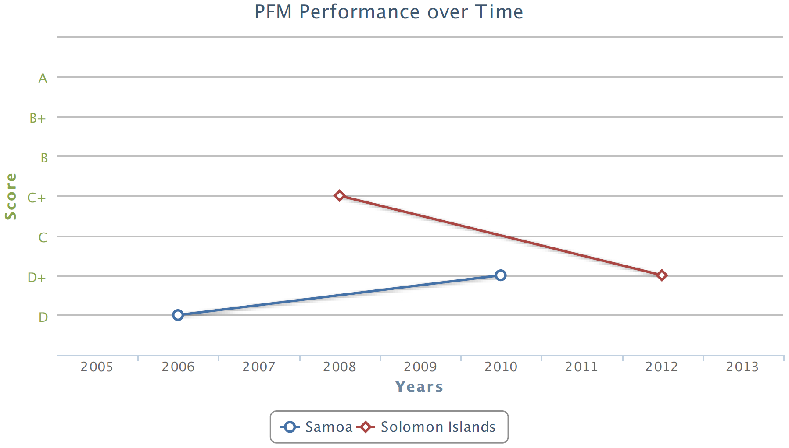
There is very limited published repeat PEFA information for PASAI. Samoa showed an increase between 2006 and 2010; however the Solomon Islands showed a decrease from 2008 to 2012.
PEFA PI-26: Scope, nature and follow-up of external audit – Rest of the World
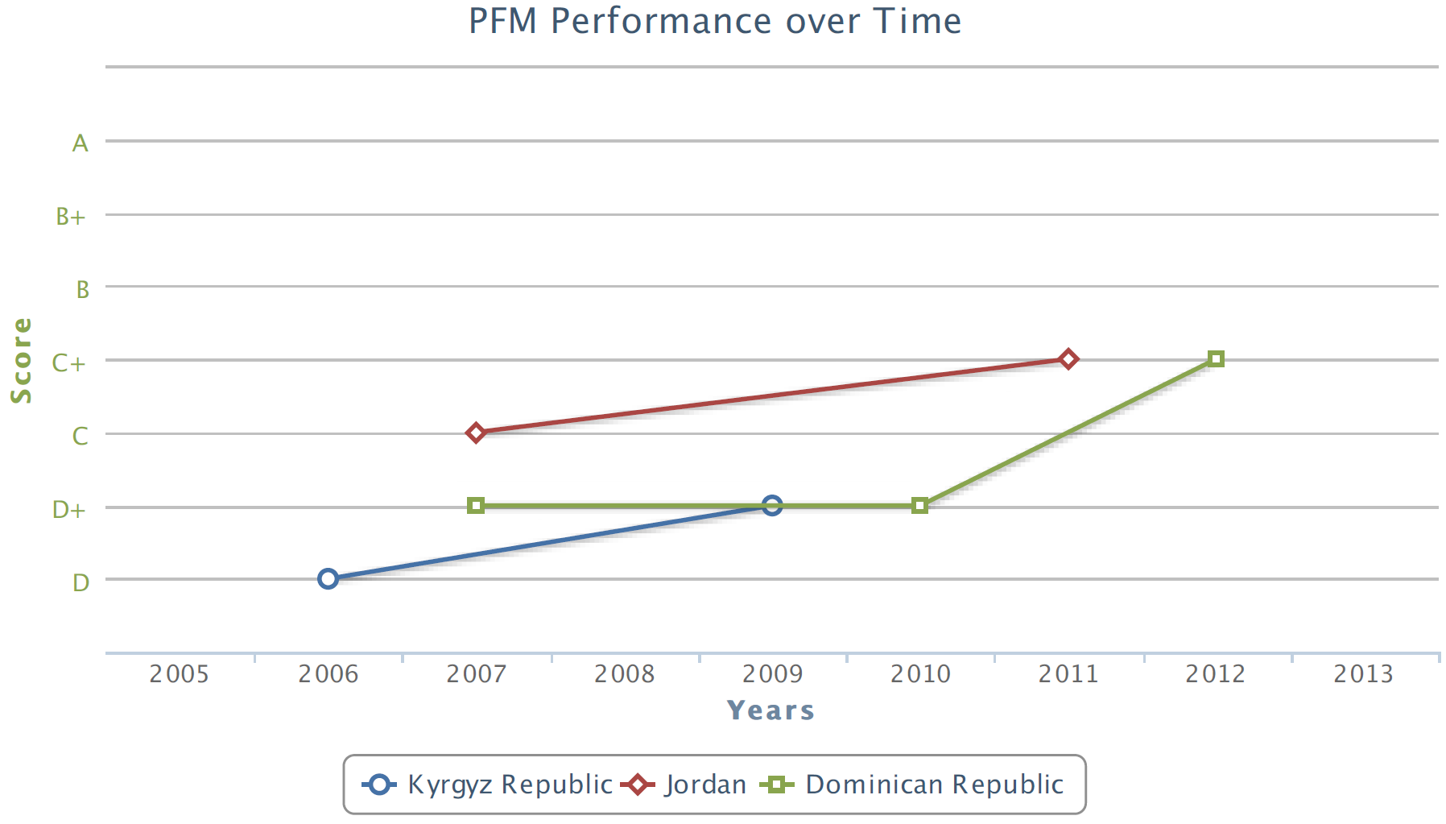
Outside these regions, there is only published repeat PEFA assessment data for the Dominican Republic (OLACEFS), the Kyrgyz Republic (ASOSAI) and Jordan (ARABOSAI). All three show a performance improvement between their latest PEFA assessments.

Reporting Against the Project Purpose: has the INTOSAI-Donor Cooperation Improved the Effectiveness and Increased the Volume of Capacity Development Support to SAIs in Developing Countries?
To contribute to the project objective of stronger SAI performance in developing countries, the Cooperation aims towards the following five initial outcomes.
- Effective SAI capacity development initiatives for better SAI performance
- Effective support to INTOSAI regional bodies
- Stronger INTOSAI knowledge networks and communities
- Global public goods developed and disseminated
- Scaled-up and more effective support to SAIs
I. Effective SAI capacity development initiatives for better SAI performance
Project Contract Indicator 6: | Evaluations of projects under the auspices of the SC demonstrate increased utilization of identified good practices and harmonization of the manner in which support is provided. | Progress: projects initiated but not yet completed hence no evaluations. Synthesis of evaluations planned for 2014. Work on the Global Call for Proposals and SAI Capacity Development Database are likely to have contributed to positive progress on this indicator.
Good practices were identified through the 2010 stocktaking and build on global aid effectiveness principles including country leadership, alignment behind country plans, and harmonisation of support. To these ends, the good practice principles formed the basis of the Global Call for Proposals as a way of ensuring they are applied in future projects. (They also form the basis for the mechanism for awarding grants under the proposed SAI Capacity Development Fund (SAI CDF)). The launch of the SAI Capacity Development Database in 2012 also strengthens the harmonization of support to SAIs. It creates a mechanism through which those considering providing support can see the ongoing, planned and proposed programs in each region and country, allowing better harmonization throughout project life-cycles, and particularly at the project planning phase. There have already been examples of potentially overlapping projects being prevented by donors and SAIs making active use of the database at the project planning phase.
The 2013 Cooperation work program includes plans to begin development of guidance on better evaluations of SAI capacity development projects, and the program document includes a synthesis of existing evaluations in 2014 to begin to collect evidence from evaluations of projects under (and outside) the Cooperation.
II. Effective support to INTOSAI regional bodies
The INTOSAI regional bodies provide an essential link between global initiatives, such as the Cooperation, and country level capacity development. They also provide a valuable resource and fora for their member SAIs. Strengthening the INTOSAI regions through direct support and partnering with them on capacity development initiatives is a key feature of the way IDI, including the INTOSAI-Donor Secretariat, works. The Cooperation has contributed to the development of the INTOSAI regional bodies in the following ways:
- Involvement of the INTOSAI regional bodies as members of the Steering Committee
- Assisting INTOSAI regional bodies to access funds for regional programs through the 2011 matching process:
  - All regions benefitting from involvement in the ISSAI Implementation Initiative, funded by the World Bank
  - AFROSAI-E management development program funded through IDI core funds (made possible through additional Sida funding)
  - Strategic Planning Program for SAIs in CREFIAF, funded by IDI core funds (made possible through additional Sida funding)
  - Development of CAROSAI strategic plan, funded by IADB
  - Development of CREFIAF strategic plan, funded by SECO
- Assisting INTOSAI regional bodies to access funds for regional programs through the global call for proposals
  - CREFIAF obtained funding from AfDB for a regional performance audit program
  - ARABOSAI is in the process of obtaining funding from USAID and IDI core funds for a regional train the trainers program and strengthening of the regional secretariat
- Involvement of AFROSAI-E and CREFIAF in the task team developing the SAI performance measurement framework
- Training for members of the CREFIAF secretariat, as well as SAIs in the CREFIAF region, on developing needs based funding applications for donors
III. Stronger INTOSAI knowledge networks and communities
INTOSAI boasts a long tradition of developing communities of practice and creating knowledge networks. The INTOSAI-Donor Secretariat acts as a knowledge centre for increasing coordination of support to SAIs, and awareness raising and communication between the INTOSAI and donor communities. The Steering Committee itself provides the main international fora in which the INTOSAI and donor communities communicate with each other. The Cooperation began development of relevant communities during 2011-12, including the SAI PMF community of practice (initially the task team and reference group). This work is planned to continue and expand during phase 2, including:
- Various activities to expand the SAI PMF community of practice
- Development of an INTOSAI community of experts on engagement with donors and developing needs based funding applications
- Development of a SAI supply side community of practice (including INTOSAI members and other providers of support to SAIs)
IV. Global public goods developed and disseminated
During phase 1, the Secretariat has been the coordinator of the INTOSAI task team developing the SAI PMF. Version 2.0 was published in September 2012, and provided the basis for global consultations and initial pilots. The Secretariat has also facilitated the sharing of existing INTOSAI global public goods with the donor community, including those developed by the IDI and INTOSAI Capacity Building Committee (CBC). With support from DFID obtained as a result of the 2011 matching, IDI has started implementing a program to roll-out selected CBC guides to different INTOSAI regions according to demand.
V. (a) More Effective Support to SAIs
Project Contract Indicator 4: | Stocktaking in 2010 and 2012 shows that higher proportion of capacity development support is based on needs identified in SAI Strategic and Development Action Plans. | Progress: global survey now expected to be undertaken in 2013, hence no formal data. However, the 2011 matching exercise led to further support for the development of strategic plans for SAIs in CREFIAF (the region where SAIs where the least likely to have such plans) and the global call for proposals ensured country level proposals where based on strategic and development action plans. Therefore positive progress has been made on this indicator.
Project Contract Indicator 5: | Stocktaking in 2010 and 2012 show that SAIs in partner countries on average are recipients of fewer but bigger and more long-term capacity development support programmes. | Progress: no evidence. While the 2010 stocktaking identified the development of long term programs and relationships as a good practice principle, the trend for alignment of support behind SAI-led plans can also lead to a larger number of small support programs, albiet within the context of developing long term institutional partnerships. The 2013 global survey may provide information on this indicator.
Most activities of the Cooperation are geared towards more effective support to SAIs. In particular, the GCP applies aid effectiveness principles and capacity development good practices to support to SAIs. The SAI capacity development database similarly contributes to improving coordination of support. The SAI PMF will enable better identification of capacity development needs, as will as better management of performance through identifying baselines and enabling monitoring of performance changes over time.
V. (b) Scaled-up Support to SAIs
Evidence on the objective of scaling up support to SAIs can be taken from the SAI Capacity Development Database. The database records budgets for SAI capacity development projects, including completed, ongoing, planned and proposed projects. INTOSAI and donor organizations responsible for providing this information are requested to update this twice per year. Based on database entries as at May 2013, the levels of budgeted and proposed SAI capacity development spending is shown below, using a three year moving average. The 2012 figures are thus based on spending for 2010-12. Figures prior to this are considered to be understated as when the database was launched, organizations focused on providing information on their current and planned projects, rather than completed projects. The figure of 41 million USD as the moving average by 2012 is taken as the baseline against which future progress is monitored. Note that the current forecasts for 2013 and 2014 may go down if planned and proposed projects do not materialize, as well as up if new projects are added.
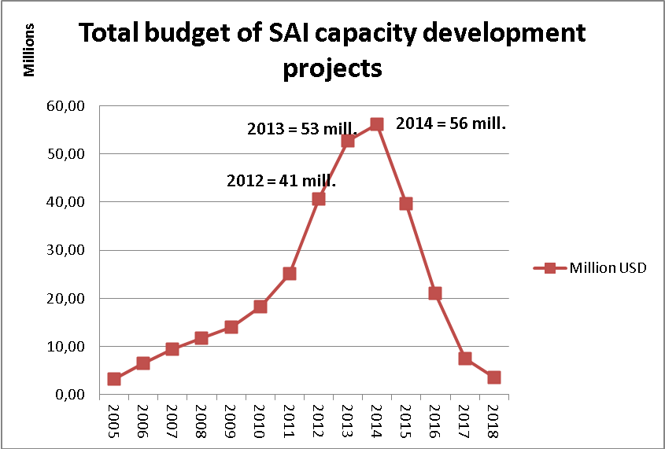
Moving three year average annual financial support for the benefit of SAIs in ODA eligible countries (forecast figures from SAI Capacity Development Database, including planned and proposed programs)
These figures appear to show a scaling up of support for SAI capacity development projects, though further monitoring will be required before a firm conclusion can be reached. It is clear from the results of the 2011 matching and the global call for proposals that donors and SAI providers have responded positively to the needs of the INTOSAI community. However, it is important to ensure that this represents an overall increase in global funding levels, rather than a redistribution of funds from one beneficiary to another.

Reporting against the 2012 Work Program
The following provides a brief progress report against the activities and outputs identified in the 2012 INTOSAI-Donor Cooperation work program.
OUTPUT 1: Update and administer the SAI Capacity Development Database
Progress as planned. The 2010 Stocktaking identified room for improvement in terms of coordination of support to the SAI community. In January 2012, a SAI Capacity Development Database on support to the SAI community was launched at www.saidevelopment.org. The database seeks to contribute to more effective global support through improved coordination of support. It builds on the former INTOSAI Capacity Building Directory, but the scope has been extended to also include support from donors and other service providers in addition to peer-peer support. The Secretariat has been responsible for the development, and hosts the databank. The ambition is to include all planned, ongoing and proposed capacity development initiatives.
265 ongoing, planned and proposed projects have been registered by SAIs, INTOSAI Regions and other INTOSAI bodies, donors and private sector suppliers. Statistics from Google Analytics shows that to date, the site has had more that 3,200 visits from 152 countries. The database has been showcased at SC meetings and in other INTOSAI and donor events, and through articles in the INTOSAI Journal and INTOSAI-Donor Cooperation Newsletters. The database has in 2012 been used for analytical purposes (including estimation of the total level of SAI capacity development support) as well as for coordination purposes in the process of matching project proposals from the 2011 Global Call for Proposals with providers of support. There is also evidence that the database is contributing to more effective support through concrete reports from providers of support that the databases has helped avert possible duplication of support. An advisory committee, comprising the SAIs of Sweden, UK and Mexico has been established to provide guidance and oversight with regards to the database.
OUTPUT 2: Matching of initiatives submitted under the Global Call for Proposals and donors
Progress as planned. In 2011, Cooperation launched a Global Call for Proposals (GCP) for SAI capacity development programmes in need of additional financing. The objective was to identify the needs of the global SAI community in the form of needs based, SAI-led proposals which ensure effective donor coordination and sound results frameworks, and then to mobilize support from development partners.
There was considerable interest in this initiative, and 55 proposals were submitted totalling 90,2 million USD. The Secretariat managed the process, including developing templates and example applications, providing support to applicants by reviewing draft proposals, and developing an overview summary of the proposals received for sharing with development partners.
In 2012, focus has been on matching the applications with providers of support. By October 2012, 44 out of 55 proposals (80%) had received at least one expression of interest from a potential provider of support. It is the obligation of interested providers and applicants to take forward bilateral matching initiatives, but the Secretariat seeks to provide assistance where necessary and demanded. This has in particular involved working with some of the regions to strengthen their proposals in dialogue with interested development partners. While this is an ongoing process which will continue in 2013, the 5th SC meeting in London in October 2012 illustrated the considerable progress made in the matching, including but not limited to:
- African Development Bank funding for CREFIAF
- USAID and IDI joint efforts to support ARABOSAI
- SAI Sweden partnering with SAI Uganda
- World Bank confirmed approval of support to SAI Moldova and the SAI of the Maldives, and ongoing dialogue related to 16 further projects
- The European Commission provided an update on dialogue on five projects
- Inter-American Development Bank emphasized their expansion of work with SAIs
- NORAD (Norway), IDI, SAI India and DFID provided further information on planned activities and ongoing dialogue on projects
The Secretariat also developed and put forward a discussion paper on future GCPs at the 5th SC meeting. The recommendations were broadly endorsed by the SC. A single mechanism for annual GCPs will be established for both individual providers and, if established, the SAI CDF. Eligible applicants will be SAIs in ODA eligible countries, as well as INTOSAI regions and other INTOSAI bodies and networks if initiatives are designed to predominantly benefit SAIs in ODA eligible countries. The GCPs will be launched at the same time each year. Applicants will first submit a concept note with an outline of the suggested project, to be developed into a more comprehensive proposal if there is interest from providers of support. The Secretariat will coordinate the process and support applicants in developing concept notes and proposals. It was also agreed that the concept papers and subsequent proposals will be submitted in parallel for consideration by individual providers and the SAI CDF. In the event that both the SAI CDF funding board and individual donors express an interest in supporting the same concept note or proposal, it was agreed that the applicants would decide which avenue to pursue.
The next GCP will be launched at the INTOSAI Congress in Beijing in October 2013. The application documents for the next global call have already been developed and published, and further support will be provided to regional groups of SAIs to develop capacity to develop needs based funding proposals (a continuation of output 9 below).
OUTPUT 3: Establish SAI Capacity Development Fund
Secretariat progress as planned, but awaiting funding commitments from donor members of the SC. The SC has promoted the creation of a global pooled fund, which would complement existing bilateral arrangements by providing capacity development financial support to SAIs in line with the principles of the MoU. The global fund would mobilize increased peer-to-peer support, enhance the coordination of support provided by the INTOSAI and donor communities, and reduce the transaction costs faced by SAIs in meeting the application and reporting requirements of multiple donor agencies. The fund would also ensure that global development resources for SAIs flow to the areas where they are most needed, and provide an opportunity for donors to support SAI capacity development in countries where they do not have the capacity to manage support projects.
The Secretariat has played a key role in the efforts to establish the SAI CDF. Operating procedures for the SAI CDF were completed in October 2012, and funding is currently being sought from interested donors for the establishment of the fund. While a number of donors have shown interest in supporting the SAI CDF, only one donor has so far committed funding. Work is ongoing to mobilize support from additional donors with the goal of announcing the SAI CDF in connection with the 2013 INTOSAI Congress.
OUTPUT 4: SAI Performance Measurement Framework – 1st draft and commence pilots
Progress as planned. Another key activity in 2012 has been to continue the work on the development of a single, global SAI PMF. This work is carried out under the auspices of the Working Group on the Value and Benefits of SAIs (WGVBS), by a task team comprising INTOSAI and donor members and coordinated by the Secretariat. It is also supported by a reference group of wider interested stakeholders from the INTOSAI, donor and civil society communities.
A mapping of existing tools was completed in December 2011. The conclusion of the mapping was that there is currently no existing tool which meets all the defined criteria for a SAI PMF. However it was evident that all criteria could be met if the strengths of a limited number of relevant frameworks were combined in a new tool. The recommendation was therefore to move forward with the work on the development of a new SAI PMF, drawing heavily on existing tools such as the AFROSAI-E capability model and the PEFA framework. The benefits from developing a global SAI PMF come from improving the ability of individual SAIs to strengthen their performance, to enhance the integrity of the SAI with external stakeholders, and to maintain external support for SAI development.
Considerable progress has been made on the development of the SAI PMF in 2012. The SAI PMF Concept Note was approved by the WGVBS and finalized and published in September 2012. Version 2.0 of the SAI PMF was also completed by the task team and was published for global consultation in September 2012. Version 2.0 of the SAI PMF has also been successfully piloted in the SAIs of Djibouti, Norway and Sierra Leone in the last half of 2012. The timetable for the work on the SAI PMF has been updated during the course of the year. Given the need for extensive piloting, the WGVBS has decided that the SAI PMF would not be tabled for formal INCOSAI approval in 2013 as originally planned. Rather, an exposure draft would be developed by the Task Team in the first half of 2013 based on comments from the global consultation and experiences from phase one pilots. This will be sent to the reference group before being submitted to the WGVBS for approval for a larger second phase of piloting and further global consultations. This exposure draft will be widely communicated at the 2013 Congress and SAIs will be encouraged to participate in a phase two pilot process that will last for two years. It is then intended to finalize the SAI PMF and present it to the INTOSAI Congress in 2016 for endorsement.

OUTPUT 5: Develop program document and funding proposal for 2013-15, for Austria, Ireland and Norway
Completed. Phase 2 program document and funding proposal drafted, approved at the fifth Steering Committee meeting and published. The program document was approved with a funding gap amounting to 31% of the three year budget. Discussions with potential donors to address this funding gap are progressing well.
OUTPUT 6: Facilitate SC leadership and SC meetings
Progress as planned.
Project Contract Indicator 7: | Semiannual SC meetings and monthly SC Leadership meetings conducted and reported upon. | Progress: Met.  SC meetings were held every 7-9 months as decided by the SC. SC leadership meetings were adjusted to every second month at the request of the leadership. All held and reported on as expected.
Project Contract Indicator 8: | Regular progress reports communicated to SC | Progress: Met.  The Secretariat provided written progress reports on specific agenda items in advance of each SC meeting, and gave a full progress report against the work program during the meeting.
In 2012 the Secretariat continued its role in facilitating SC meetings and SC leadership meetings. Two SC meetings have taken place in 2012, with the 4th SC meeting being hosted by the SAI of India in February, and the 5th SC meeting being hosted by the SAI of the United Kingdom in October. Key summary points and press releases were distributed on the day of each meeting, and full meeting minutes afterwards. Preparations for the 6th meeting, which is scheduled to take place just ahead of the INTOSAI Congress in October 2013, are also underway.
The SC leadership (comprising the joint Chairs, Vice Chairs and the Secretariat) have throughout 2012 held bimonthly teleconferences to follow up on progress and provide direction for the initiative. Summaries of these meetings have been shared with the funding donors and the IDI Board.
OUTPUT 7: Support CBC work on strengthening SAI supply side
Progress as planned. There has long been recognition of the potential to both scale up and enhance the quality of the supply side of support to SAIs. This is a multifaceted area which includes:
- Encouraging established providers to expand their support and push the boundaries of the effectiveness and impact of their support.
- Assisting emerging providers to become established providers adopting agreed good practices.
- Encouraging new providers to enter the supply side.
- Ensure all active providers – whether SAIs, INTOSAI regional bodies, other public bodies or private sector suppliers – remain up to date on both technical INTOSAI knowledge and capacity development approaches.
- Addressing the supply side gaps that exist in specific regions, languages and technical skills areas.
Following the 4th SC Meeting, the Chair of the CBC, in cooperation with the Secretariat, the CBC Goal Liaison and OAGN arranged a supply side seminar in Oslo in September 2012. At the seminar, a number of existing and emerging SAI providers shared their experiences and ideas. The purpose of the meeting was to set a road map towards strengthening the supply of support to SAIs, and to identify a number of concrete initiatives to take this forward. The 5th SC meeting endorsed the seminar recommendations and agreed to further investigate the following:
- Establishment of a Community of Practice: Providers of support to SAIs should come together in a Community of Practice, possibly including the hosting of regular technical updates to ensure all providers are kept up to date with technical developments in INTOSAI and approaches to capacity development. It is tentatively proposed to establish such a practice and to hold a technical update each November from 2013 onwards.
- Program and project evaluation: The seminar revealed the need for more evidence-based knowledge about success factors of support to SAIs. This could include producing a synthesis of existing evaluations to identify common themes, and contributing to possible work with SAI Sweden and Norway to develop specific guidance on the evaluation of SAI capacity development projects.
OUTPUT 8: Awareness raising and communication activities targeting INTOSAI and Donors
Progress as planned.
Project Contract Indicator 9: | Information material developed and distributed. | Progress: Met.
Project Contract Indicator 10: | Regular attendance at INTOSAI and Donor Forums to inform about cooperation. | Progress: Met.
The Secretariat has also continued to prioritize communication and awareness raising in 2012. Four editions of the quarterly INTOSAI-Donor Cooperation newsletter were distributed in 2012. The interest for the Newsletter is growing, and the number of recipients on the mailing list has increased significantly. The Cooperation also has a regular feature in the INTOSAI Journal, with the May edition focusing on the SAI Capacity Development Database and the October edition on the SAI PMF. Efforts have also been made to expand the information available on the Cooperation at the IDI web page, including the development of generic presentations on the Cooperation, the SAI PMF and the pooled fund.
The Secretariat also utilizes opportunities to present the Cooperation in INTOSAI and Donor forums. Presentations in 2012 have been provided in the CBC Steering Committee, at the USA GAO Fellowship programme, in CAROSAI, and at the World Bank Fiduciary Forum and Learning Week. The Secretariat has also cooperated with the SC leadership in maintaining a close dialogue with potential new signatories to the MoU. During 2012 the Asian Development Bank, AusAID and GAVI became signatories to the MoU.
OUTPUT 9: Building capacity of SAIs to develop funding proposals
Progress as planned. The Global Call for Proposals revealed a strong need in some INTOSAI regions and in many SAIs for support in engaging with the donor community, including in developing sound and results-focused funding proposals. This will contribute to better programs through improved design and delivery, through its regional approach it can facilitate stronger regional networks that can help their members assess needs and access funding, and the course material will constitute a global public good which can be actively used by SAIs and donors.
Following a request from CREFIAF, the Secretariat developed and delivered (in French) a two day course on developing funding proposals, which was offered to CREFIAF member countries in connection with the CREFIAF General Assembly in Congo Brazzaville in July 2012. Feedback from the course suggests it was highly appreciated, and it is planned to be offered in conjunction with the next GCP to be launched at the INTOSAI Congress in Beijing in 2013, in various INTOSAI regions subject to demand. It was agreed at the 5th SC meeting that these courses also should have the objective of developing the capacity of INTOSAI regional bodies to support their member SAIs. Therefore, going forward, this will be delivered (where demanded) in two-parts: first, training experts from INTOSAI regions and regional bodies, then assisting regional experts to deliver training to their member SAIs.
OUTPUT 10: Acting as a knowledge centre and repository to enhance coordination of support to SAIs
Progress as planned. The Secretariat is increasingly serving as a knowledge and competency centre for donors and SAIs and raising awareness of INTOSAI within the development community. Numerous requests are being received from donors and SAIs. A small sample from 2012 include, providing donors with information supporting their works in Tanzania, Iraq, Pakistan, and ARABOSAI, communicating SAI capacity building opportunities to potential providers, supporting SAIs in identifying peer providers of support, and following up on alleged SAI independence infringements. There has also in 2012 been a marked increase in the communication with private providers of capacity building support to SAIs, who seek guidance and technical advice on the INTOSAI standards and developments within INTOSAI.
Following the Secretariats role in coordinating INTOSAI’s involvement in the 4th High Level Forum on Aid Effectiveness in Busan in late 2011 and the increased importance attached to INTOSAIs cooperation with the broader development community, an interim arrangement was decided in early 2012 within INTOSAI where the Chair of the Capacity Building Committee and the INTOSAI-Donor Secretariat serve as focal points for the cooperation with the OECD DAC and broader development community. The INTOSAI Governing Board decided in November 2012 that the CBC Chair and the Secretariat would continue in this role. As a follow up from Busan, the Secretariat has continued to play a role in the cooperation with the development community, including representing INTOSAI at the OECD Global Forum on Development and on the Building Block on Effective Institutions. The cooperation also extends to other development initiatives such as GIFT, PEFA and the PFM sub-group of ‘Learn4Dev’ - a joint donors’ competency development network.
OUTPUT 11: Review of funding levels of SAIs (possibly linked to future INTOSAI stock taking)
No progress. Identified as a low priority activity in the work program. As noted above, a future global survey has not yet been undertaken but is expected in the second half of 2013. In the design of this survey, the possibility of incorporating a review of SAI funding levels will be explored.
OUTPUT 12: Explore the question of SAI involvement in the audit of revenue from extractive industries and INTOSAI engagement with the Extractive Industries Transparency Initiative (EITI)
In progress. Identified as a low priority activity in the work program. During 2012, detailed ToRs for the work were drafted. At the 5th SC meeting in October 2012, it was agreed to continue this work through the following activity: “SAI involvement in audit of extractive industries – mapping and way forward”, as a joint activity between the Secretariat and AFROSAI-E. Work commenced in late 2012 and following a survey, a first draft report was shared with the SC leadership in May 2013.

Financing

Overall Financial Position, 2010-12
Total funding and expenditure for the INTOSAI-Donor Secretariat for the 31 months June 2010 to December 2012 is shown below. As at 31 December 2012, 2 966 NOK remains unspent and is requested to be carried forward to phase 2 of the INTOSAI-Donor Cooperation.
 | 2010 | 2011 | 2012 | Total
Financing:
Austria (€150 000 in 2010 and 2012) | 1 181 550 | - | 1 106 175 | 2 287 725
Ireland (€200 000 in 2010, 2011 and 2012) | 1 601 000 | 1 543 200 | 1 457 580 | 4 601 780
Norway | 1 600 000 | 2 500 000 | 1 000 000 | 5 100 000
Interest received on prior year cash balances:
Austria | - | 3 962 | - | 3 962
Ireland | - | 5 368 | 9 689 | 15 057
Norway | - | 5 365 | 15 696 | 21 061
Total Available Funds | 4 382 550 | 4 057 895 | 3 589 140 | 12 029 585
Expenditure | 1 454 830 | 4 698 246 | 5 873 543 | 12 026 619
Unspent grant carried forward, 31 Dec | 2 927 720 | 2 287 369 | 2 966 | -
Donor Contribution Percentage (Including Interest) | Austria | Ireland | Norway | Total
2010-2012 | 19 % | 38 % | 43 % | 100%
All figures in Norwegian Kroner
Total expenditure against budgeted funds and allocation per donor is shown below for 2012. Similar analysis for 2010 and 2011 was provided in the previous annual progress reports.
 | Austria | Ireland | Norway | Total
Unspent grant carried forward |  |  | 2 287 369 | 2 287 369
Expected Financing, based on 1 Jan exchange rate | 1 162 500 | 1 550 000 | 1 000 000 | 3 712 500
Budget to IDI Board | 1 162 500 | 1 550 000 | 3 287 369 | 5 999 869
Exchange rate movement 1 Jan to 13 Feb | -25 305 | -33 740 |  | -59 045
Revised budget to donors, 26 June 2012 | 1 137 195 | 1 516 260 | 3 287 369 | 5 940 824
Additional exchange rate movement on funds received | -31 020 | -58 680 |  | -89 700
Interest on 2011 balances, spent in 2012 |  | 9 689 | 15 696 | 25 385
Available Funds | 1 106 175 | 1 467 269 | 3 303 065 | 5 876 509
Expenditure | 1 106 175 | 1 464 303 | 3 303 065 | 5 873 543
Unspent grant carried forward, 31 Dec 2012 | - | 2 966 | - | 2 966
All figures in Norwegian Kroner

Budget Execution, 2012
Following approval of the 2011 progress report, a revised project budget was submitted to the donors on 26 June 2012. It was approved by the three donors (the Austrian Development Agency formally approved the revised budget in a letter dated 5 July 2012). An analysis of actual expenditure against budget and an explanation of major variances for 2012 is presented below.
 | Budget 2012 | Expenditure 2012 | (Under) / Over Spend | (Under) / Over Spend (%)
Item No. 1: Payroll and Related Costs
Total Payroll and Related Costs | 3 908 970 | 3 813 744 | (95 225) | (2%)
Item No. 2: Travel and Accommodation Costs
Total Travel and Accommodation Costs | 450 000 | 645 233 | 195 233 | 43%
Item No. 3: Other Operating Costs
Participation fees, Seminars, Subscriptions | 2 500 | 22 380 | 19 880 | 795%
Arranging Meetings, Workshops | 10 000 | 63 178 | 53 178 | 532%
Translation of Documents | 250 000 | 260 837 | 10 837 | 4%
Printing of Publications | 10 000 | 1 557 | (8 443) | (84%)
Rent/ Electricity/ Security/ Stationary/ Insurance | 406 049 | 412 351 | 6 302 | 2%
Telecommunication/ internet | 309 115 | 323 738 | 14 623 | 5%
IT equipment & software | 25 000 | 0 | (25 000) | (100%)
Hosting of website and databank | 75 000 | 30 869 | (44 131) | (59%)
External consulting services | 250 000 | 298 002 | 48 002 | 19%
Other costs | 0 | 1 654 | 1 654 | N/A
Total Other Operating Costs | 1 337 664 | 1 414 566 | 76 902 | 6%
Item No. 4: Contingency
Total Contingency | 244 190 | 0 | (244 190) | (100%)
Primary Expenditure | 5 940 824 | 5 873 543 | (67 280) | (1%)
Interest received | 25 385 | - | (25 385)
Exchange rate losses versus budget | (89 700) | - | 89 700
Final Expenditure | 5 876 509 | 5 873 543 | (2 966) | (0.05%)
All figures in Norwegian Kroner
Major expenditure variations were:
- Payroll: reimbursement for costs of Head of INTOSAI-Donor Secretariat during paternity leave, partly offset by associated overspend on staff overtime
- Travel and accommodation: SAI PMF costs in final quarter not budgeted for, mainly three people to Sierra Leone and three people to Djibouti for SAI PMF pilots, plus cost of attendance at OLACEFS capacity building committee meeting in Peru to present SAI PMF. Budgeted to allocate costs to World Bank ISSAI grant, SAI PMF component; instead used this money for ISSAI program and used available funds under INTOSAI-Donor Secretariat for SAI PMF.
- Participation fees, seminars and subscriptions: two staff sent on externally organized public financial management training courses in London and Oslo, 20 000 NOK, not budgeted for.
- Arranging meetings and workshops: hosting training for SAIs in CREFIAF on developing needs based capacity development proposals, 49 000 NOK, not budgeted for.
- Printing of publications: no major publications printed.
- IT equipment and software: no costs for INTOSAI-Donor Secretariat during 2012.
- Hosting of website and databank: consultancy costs for supporting the SAI Capacity Development website and database less than expected.
- External consultancy services: development of SAI PMF training material started December 2012 rather than January 2013, 48 000 NOK in December.
- Contingency: used to cover exchange rate losses (90 000 NOK) and overspend on travel and accommodation, and consultancy
IDI’s financial statements have been audited and an unqualified audit opinion was given. The approved financial statement of IDI, with particular notes related to the Secretariat, is included as Annex A and Annex B. The contributions to and expenditures of the Secretariat were audited as part of the overall audit of the IDI. The original and signed audit report in Norwegian and the audit report in English is included as Annex C.

Budget Execution, 2010-12
Total expenditure for the 31 months June 2010 to December 2012 by category is shown below, in Norwegian Kroner and then also in Euros (converted from kroner values using 31 December 2012 exchange rate).
 | Norwegian Kroner |  |  |  | Euros (using 31 Dec 2012 exchange rate €1=7,35 NOK)
Cost items according to the contract | Expenditure 2010 | Expenditure 2011 | Expenditure 2012 | Expenditure 2010-12 | Expenditure 2010 | Expenditure 2011 | Expenditure 2012 | Expenditure 2010-12
Item No. 1: Payroll and Related Costs
Total Payroll and Related Costs | 997 731 | 3 148 886 | 3 813 744 | 7 960 362 | 135 746 | 428 420 | 518 877 | 1 083 042
Item No. 2: Travel and Accommodation Costs
Total Travel and Accommodation Costs | 303 898 | 379 678 | 645 233 | 1 328 809 | 41 347 | 51 657 | 87 787 | 180 790
Item No. 3: Other Operating Costs
Participation fees, Seminars, Subscriptions | 0 | 1 619 | 22 380 | 23 999 | 0 | 220 | 3 045 | 3 265
Arranging Meetings, Workshops | 0 | 750 | 63 178 | 63 928 | 0 | 102 | 8 596 | 8 698
Translation of Documents | 59 339 | 220 085 | 260 837 | 540 261 | 8 073 | 29 944 | 35 488 | 73 505
Printing of Publications | 30 636 | 3 950 | 1 557 | 36 143 | 4 168 | 537 | 212 | 4 917
Rent/ Electricity/ Security/ Stationary/ Insurance | 0 | 413 399 | 412 351 | 825 750 | 0 | 56 245 | 56 102 | 112 347
Telecommunication/ internet | 0 | 284 489 | 323 738 | 608 227 | 0 | 38 706 | 44 046 | 82 752
IT equipment & software | 59 275 | 22 644 | 0 | 81 919 | 8 065 | 3 081 | 0 | 11 145
Hosting of website and databank | 3 950 | 6 900 | 30 869 | 41 719 | 537 | 939 | 4 200 | 5 676
External consulting services | 0 | 215 776 | 298 002 | 513 778 | 0 | 29 357 | 40 544 | 69 902
Professional fees (evaluation) | 0 | 0 | 0 | 0 | 0 | 0 | 0 | 0
Other costs | 0 | 69 | 1 654 | 1 723 | 0 | 9 | 225 | 234
Total Other Operating Costs | 153 200 | 1 169 682 | 1 414 566 | 2 737 448 | 20 844 | 159 140 | 192 458 | 372 442
Item No. 4: Contingency
Total Contingency | 0 | 0 | 0 | 0 | 0 | 0 | 0 | 0
TOTAL | 1 454 829 | 4 698 246 | 5 873 543 | 12 026 619 | 197 936 | 639 217 | 799 122 | 1 636 275

EXPLANATION OF MAJOR DEVIATIONS

The Secretariat has in the course of 2012 not registered any major deviations from the 2012 Work Program. As noted in section 3.2 above, a revised project budget was submitted to the donors on 26 June 2012. It was approved by the three donors (the Austrian Development Agency formally approved the revised budget in a letter dated 5 July 2012).

ASSESSMENT OF PROBLEMS AND RISKS
Both the project document and Annex 1 to the joint financing agreement contain deliberations on risks and risk mitigation. In 2012 none of the identified risks were manifested in ways that negatively impaired the performance of the Secretariat. For phase 2 of support to the INTOSAI-Donor Cooperation, assumptions and the identification and planned management of risks are documented in section 8 of the 2013-15 program document, and approved by the Steering Committee.
Risks and mitigation measures

Below are tables summarizing the internal and external risks identified in the program document and a description of the actual position in 2012 as well as actions taken to mitigate them where this has been necessary.

No. | Risk factor (internal) | Actual position 2012 | Mitigation measures
1 | Reluctance to and/or inability of donors and SAIs to compile and provide complete and transparent information on SAI development activities and funding levels. | The risk has not materialized. The database on SAI capacity development was launched in January 2012 and more than 265 projects have now been entered into it. The 2010 stocktaking had a high response rate. No information has yet been requested on SAI funding levels.
2 | Inadequate funding to implement Work Program. | Not materialized during phase 1. There is a funding gap for phase 2. | Dialogue with a number of potential donors on addressing this gap is well advanced.
3 | Lack of available data on good practices and lessons learnt in terms of SAI capacity development. | Not materialized.
4 | Identified good practices are utilized uniformly without adequate consideration of the specific circumstances facing the recipient. | Not materialized.
5 | Inadequate Secretariat resources, capacity and skills. | The Secretariat experienced inadequate staffing levels in the later half of 2011 after the launch of the Global Call for Proposals, as well as at points during 2012. | Entered into framework agreements and made use of external consultants in the review of draft applications and development of various training courses. Increased Secretariat staffing by one from October 2012.

No. | Risk factor (external) | Actual position 2012 | Mitigation measures
1 | Donor community does not follow up on commitment to make additional funding available for support to SAIs in partner countries. | Does not appear to have materialized, though needs to be continually monitored.  However, there is as yet limited support for pooled funding arrangements, with just one donor willing to commit to a pooled fund. | The SAI capacity development database provides the mechanism for monitoring this risk.  The Secretariat issued a funding request for pooled funds during 2012 and will do so again in 2013.
2 | SAIs in partner countries lack the institutional capacity and knowhow to effectively implement capacity development support. | Risk is expected to materialize in relation to SAI level projects. As yet, there have been few evaluations of SAI level projects under the Cooperation. This is expected in phase 2, and the planned synthesis of project evaluations will shed light on this. | 1. More regional programs and support for stronger regional structures in regions with inexperienced SAIs.  2. Ensure the SAI’s implementation capacity is taken into consideration when SAI strategic plans and support programs are designing.  3. Ensure strong country demand for and ownership of initiatives, and support provided in a harmonized manner with a clear lead and allocation of responsibilities among providers of support. Also provide support to development of capacity for planning and managing support within the SAI.
3 | Lack of adequate SAI ownership and support not being sustainable and demand driven. | Addressing this challenge is the essence of the rationale for the INTOSAI-Donor cooperation. SAI ownership and demand has been put at the heart of processes such as the Global Call for Proposals and the focus on strengthening SAI strategic planning (from the 1st round of matching). SAIs are increasingly taking ownership and programs are more demand driven. On sustainability, the approaches used and good practices promoted through all INTOSAI-Donor activities are geared towards enhancing sustainability, but the extent to which sustainability is actually achieved can not be known until after various SAI capacity development activities have been completed and appropriate evaluations conducted. A synthesis of SAI project evaluations is planned for 2014, and an impact assessment is planned for 2014-15. | Aim of Global Call for Proposals was to bring forward SAI-led and demand driven initiatives.  Initiatives financed by the pooled fund will mainly be recipient executed.  Focus on SAI-led strategic plans aims to promote SAI ownership and sustainability.  The priorities and good practice principles adopted in the Global Call for Proposals are geared towards sustainable development.  Actual sustainability needs to be monitored in the future through impact assessments.
4 | Reluctance to and/or inability of donors and SAIs to compile and provide complete and transparent information on SAI development activities and funding levels. | The risk has not materialized. The database on SAI capacity development was launched in January 2012 and to date more than 260 projects had been entered into it. The 2010 stocktaking had a high response rate.

Repeat PEFA assessments are not recommended to be conducted more frequently than once every three years. Therefore a reasonable time period must be taken to obtain a large sample of repeat assessments.
The Head of the INTOSAI-Donor Secretariat is also the IDI Deputy Director of Administration and External Relations, working 50% on each task.
The meeting was hosted in conjunction with the third INTOSAI-Donor Steering Committee Meeting in July 2011, with participants from Ireland, Norway and the Secretariat.
This consisted of: 1) Administer and facilitate SC meetings, 2) Assist the SC in drafting a Joint Work Program and possibly Operational Guidelines , 3) Ensure effective communication within the Cooperation and with stakeholders, 4) Carry out information and awareness raising activities , 5) Take stock and maintain an overview of: a) country owned strategic and development action plans, b) inventory of capacity building projects undertaken, c) identified funding gaps, 6) Assemble collection of examples of good practices of capacity building of the INTOSAI community
Available at http://www.idi.no/artikkel.aspx?MId1=128&AId=842
These initiatives respond to findings of a 2012 multi-donor evaluation of public financial management (PFM) reform in Ghana, Malawi and Burkina Faso, which noted the lack of measurable indicators within PFM reform programs undermined efforts to evaluate both the success of PFM reforms and the success of donor support to those reforms.
For 2010, with an intention to review its longer term engagement
Around euro 1 050 000
Addenda No 1 and No 2 to the financing agreement
See earlier in this document, it has been agreed that the work program agreed by the SC replaces the extended secretarial functions outlined in the joint financing agreement.
The INTOSAI Information Database is a project led by SAI Mexico to develop a global database of information about SAIs, which potentially could provide synergies with a future global survey. A decision on how and when to proceed with a global survey will be made after the annual meeting of the INTOSAI Information Database task force in Peru in July 2013.
Based on the latest PEFA assessment available in that country (published or unpublished), extracted from PEFA monitoring spreadsheet provided by PEFA Secretariat
Obtained May 2013 from the PEFA Secretariat, this is the latest available PEFA data
Income classifications based on OECD-DAC classification for 2011, 2012 and 2013 aid flows (e.g. the same classification is used for both points in time)
‘Evaluation of Donor Support to Public Financial Management (PFM) Reform in Developing Countries: Analytical study of quantitative cross-country evidence’ November 2010, Paolo de Renzio, Matt Andrews, Zac Mills
No scores at the dimension level have been removed from this analysis.
http://www.pefa.org/en/dashboard
Kosovo is not a member of INTOSAI or EUROSAI, but has benefitted from substantial bilateral support from both the INTOSAI and donor communities.
A finalized, but as yet unpublished, 2011 PEFA assessment for Moldova shows a score of B+ for PI-26, representing an improvement from the previous assessment.
http://www.idi.no/artikkel.aspx?MId1=98&AId=628
http://www.saidevelopment.org/default.aspx
http://www.idi.no/artikkel.aspx?MId1=98&AId=628
A fuller description of the proposal for the SAI CDF is provided at http://www.idi.no/artikkel.aspx?MId1=109&AId=768
Version 2.0 of the SAI PMF and the SAI PMF Concept Note are at http://www.idi.no/artikkel.aspx?MId1=102&AId=704
http://www.idi.no/artikkel.aspx?MId1=128&AId=842
Assumed exchange rate of €1 = 7,75 NOK
Exchange rate at 13 Feb 2012 of €1 = 7,5813 NOK
Received 1 457 580 NOK from Ireland and 1 106 175 NOK from Austria
One of the positions in the Secretariat is financed by the Office of the Auditor General of Norway in the form of a secondment, whose costs are not included in the INTOSAI-Donor Secretariat budget.

