INTOSAI-DONOR COOPERATION: PHASE 2 (2013-15)
PERFORMANCE AND FINANCIAL REPORT 2013
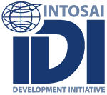

INTOSAI-DONOR SECRETARIAT

20 NOVEMBER 2014

Version Control Sheet

Version No. | Purpose | Date | Authorized By
1.0 | Submitted to donors for approval | 31 May 2014 | M Aldcroft
2.0 | Revised version reflecting comments from donors, resubmitted to donors for approval | 20 Nov 2014 | M Aldcroft

Note on Use of Version Control
Updated versions for internal purposes would be 1.0, 1.1, 1.2 etc.
Updated versions for external stakeholders would be 1.0, 2.0, 3.0, etc.
TABLE OF CONTENTS
ANNEXES 4
ACRONYMS 4
EXECUTIVE SUMMARY 5
1. INTRODUCTION 7
1.1 Report Purpose 7
1.2 INTOSAI-Donor Cooperation Background 7
1.3 Results Framework and Logframe for Reporting 7
1.4 Financial and Other Support for the INTOSAI-Donor Cooperation (Phase 2) 10
1.5 INTOSAI-Donor Cooperation Governance Arrangements 11
2. INTOSAI-Donor Cooperation Performance Report, 2013 13
2.1 Levels of Results Reporting 13
2.2 Reporting Against Program Purpose: Improved SAI Performance in Developing Countries 14
2.3 Reporting Against Expected Results: Scaled-up and More Effective Support 16
2.3.1 Effective Capacity Development Initiatives for Better SAI Performance 16
2.3.2 Effective Support to INTOSAI Regions 16
2.3.3 Stronger INTOSAI Knowledge Networks and Communities 17
2.3.4 Global Public Goods Developed and Disseminated 17
2.3.5 Scaled-up and more effective support 17
2.4 Reporting Progress against the Work Program Themes 19
2.4.1 Theme 1: INTOSAI-Donor Cooperation Management 20
2.4.2 Theme 2: Funding Mechanisms and Project Identification 20
2.4.3 Theme 3: SAI Performance Measurement Framework 21
2.4.4 Theme 4: Knowledge Centre on Support to SAIs 23
2.4.5 Theme 5: Strengthening the Supply of Support to SAIs 26
2.4.6 Theme 6: SAI Research Agenda 26
2.4.7 Theme 7: Monitoring and Evaluation 27
2.5 Cross-Cutting Observations on Sustainability and Gender 28
3. INTOSAI-Donor Cooperation: Financial Report, 2013 30
3.1 Budget and Initial Financing Gap, 2013-15 30
3.2 Financing Received and Future Commitments 31
3.3 Budget Execution, 2013 32
3.4 Income and Expenditure per Donor, 2013 34
3.5 Estimate of Available Financing per Year, 2013-15 35
3.6 Proposed Revised Budget, 2013-15 35
3.7 Future Matters Under Consideration to Improve IDI Financial Management and Reporting 39
4. EXPLANATION OF MAJOR DEVIATIONS 41
5. MANAGEMENT OF INTERNAL AND EXTERNAL RISKS 41
6. PROPOSED ADJUSTMENTS TO AGREED PLANS 42

ANNEXES
Annex A: INTOSAI-Donor Cooperation Logframe, as at 31 December 2014
Annex B: Signed English Financial Statements for IDI 2013
Annex C: English notes to Financial Statements for IDI 2013
Annex D: Signed Norwegian Auditors Report for IDI 2013
Annex E: Translated English Auditors Report for IDI 2013

ACRONYMS
ADA Austrian Development Agency
CBC Capacity Building Committee
Cooperation INTOSAI-Donor Cooperation
Database SAI Capacity Development database
DFID Department for International Development (UK)
EITI Extractive Industries Transparency Initiative
GCP Global Call for Proposals
IDI INTOSAI Development Initiative
ISSAIs International Standards of Supreme Audit Institutions
INTOSAI International Organization of Supreme Audit Institutions
LDC Least Developed Countries
LI Low Income Countries
LMI Lower Middle Income Countries
MoU INTOSAI-Donor Memorandum of Understanding
NORAD Norwegian Agency for Development Cooperation
OAGN Office of the Auditor General of Norway
PD Program Document
PEFA Public Expenditure and Financial Accountability
PMF Performance Measurement Framework
ToRs Terms of Reference
SAI Supreme Audit Institution
SAI CDF SAI Capacity Development Fund
SC INTOSAI-Donor Steering Committee
SECO State Secretariat for Economic Affairs (Switzerland)
Secretariat INTOSAI-Donor Secretariat
UMI Upper Middle Income Countries
WB The World Bank
WGVBS Working Group on the Value and Benefits of SAIs

EXECUTIVE SUMMARY
This report summarises the performance and financial position of the INTOSAI-Donor Cooperation against the Program Document 2013-15, logframe and 2013 work plan, to meet the contractual requirements of the funding donors.
SAI Performance Improving in Developing Countries
The purpose of the Cooperation is to improve the performance of SAIs in developing countries. 2013 data shows SAI performance is improving, on most indicators and in most income groups. Global SAI performance data shows significant improvements in external audit systems from 2010 to 2013 (PEFA PI-26) in low and lower middle income countries, though little change in upper middle income countries. Comparing the 2013 IDI global survey to the 2010 INTOSAI stock taking shows middle income countries increasingly issuing their annual audit reports within legal timeframes, but a decline in low income countries. And data from published PEFA assessments (PEFA PI-10 criteria iv) shows significant increases in the timely publication of annual audit reports in all income groups.
Scaled-up and More Effective Support for SAI Capacity Development
The Cooperation seeks to improve SAI performance through scaling-up and increasing the effectiveness of support to SAIs. The average annual value of support for SAI capacity development jumped from US $41 million in 2012 to $48 million in 2013, and a SAI Capacity Development Fund has been established with funding already pledged from Switzerland.
The Cooperation has prioritised development of SAI-led strategies and development action plans since 2010, and now almost all SAIs have these in place: in low income countries, the percentage of SAIs with strategic plans has rocketed from 63% to 98%. Tentative evidence suggests that in most countries, all support is now aligned with these SAI-led plans.
The Cooperation recognises the nature of INTOSAI as a global peer partnership, and the role of diverse stakeholders in supporting SAI capacity development. Evidence shows a strengthening of INTOSAI regions, with more regions accessing external support, and the Cooperation improving skills of regional bodies and knowledge networks in areas such as use of performance measurement (such as the SAI PMF), and developing needs based funding applications. The Cooperation has successfully developed and disseminated a number of global public goods during 2013, not least the SAI PMF Pilot version, and an influential report on Extractive Industries Audit, which led to formation of an INTOSAI working group.
Work to strengthen the design and delivery of support to SAIs is in progress. In 2013, a training course for donor staff on working with SAIs was designed, though the first pilot was delayed and instead took place in early 2014. Work has also begun to develop guidance for better evaluations of SAI capacity development initiatives, in an effort to improve the design of projects including use of results frameworks, and encourage more and better independent evaluations. However, following a SC decision in 2013, the Cooperation has not yet begun efforts to strengthen the supply of support provided to SAIs.
Strong Progress on High Priority Tasks in 2013
The 2013 work program gave high priority to the following tasks, which were successfully delivered by the Secretariat and others. Theme 1: Cooperation management, including hosting the 6th SC meeting, bi-monthly SC leadership teleconferences, and communication activities. Theme 2: funding mechanisms and project identification, under which the 2013 Global Call for Proposals was successfully launched and progress made on establishing the SAI Capacity Development Fund. Theme 3: SAI PMF, which was approved for piloting and published in July, rolled-out through eight one-week training courses reaching over 200 SAI and donor staff and consultants in all regions of the world, and saw several SAIs begin their pilots, while many more prepared to do so. And within theme 4, the Secretariat continued to ensure the SAI Capacity Development was kept up to date to make it an effective tool for better coordination.
Positive External Evaluation
An external evaluation of IDI was published in 2013. It reported that stakeholders were very satisfied with the performance of the Secretariat, though it had very ambitious expected results. It concluded that the achievements of the Secretariat would not have been possible had it not been located within IDI “because the success of these activities depends on the participation of the SAIs, who know IDI”.
Financing Gap for the Cooperation Resolved – but led to Large Underspend in 2013
The Cooperation began 2013 with a US $1.3 million (7.9 million NOK) financing gap (31% of the 2013-15 budget). From July onwards, the Secretariat faced a tight financial position and was forced to cancel or delay various activities. Grant agreements which fully addressed the financing gap were signed in October, but cash only received from mid-December. Given the uncertain financial position for much of the year, and late receipt of funds, the Cooperation’s overriding financial goal in much of 2013 was to minimise expenditure. The Secretariat was kept afloat by use of IDI core funds and an advance on 2014 funding from Ireland. This resulted in a underspend against the budget of US $168,000 (1 million NOK).
Budget Amendment: Request for Available Funding to be used to Address Vacancies in the Secretariat
The underspend in 2013, combined with the additional financing pledged, favourable exchange rate movements, and gradual release of the exchange rate contingency, leave an excess of US $422,000 (2.5 million NOK) of forecast funding compared to the current budget. Section 3.6 details the many budget changes required at this mid-point in phase two of the Cooperation, and proposes a revised budget for 2013-15, for which written donor approval is sought. This revised budget will enable the Secretariat to address the high staff vacancy levels that look set to characterise most of 2014.
Significant New Risk to Cooperation Success to be Carefully Managed
Section 5 considers the management of internal and external risks, and updates the risk register from the program document. A new key risk has emerged during 2013: ‘that donors and SAI providers impose SAI PMF assessments on developing country SAIs, reducing ownership of the SAI PMF and leading to it being regarded as a donor tool, reducing its eventual use’. The Secretariat suggests that this issue is continually raised in appropriate events, such as SAI PMF training, SC meetings, and other appropriate fora, to advocate for proper use of the SAI PMF for the benefit of all.

INTRODUCTION

Report Purpose
Austria, Ireland, Norway, Switzerland and the UK have provided core funding to support phase two of the INTOSAI-Donor Cooperation (2013-15), through grants to the INTOSAI-Donor Secretariat within the IDI. In addition, the World Bank has provided earmarked funds for certain activities under the Cooperation, and the SAIs of Norway and Brazil have provided staff as in-kind support. The purpose of this report is to fulfil the reporting requirements set down in the Program Contract, through reporting on performance, progress, and the use of funds during 2013.

INTOSAI-Donor Cooperation Background
Recognizing the importance of well functioning, multidisciplinary and independent SAIs, and that support to SAIs from both the INTOSAI and Donor communities could be more effective, the International Organization of Supreme Audit Institutions (INTOSAI) and 15 Donors signed a landmark Memorandum of Understanding (MOU) to augment and strengthen support to SAIs in developing countries in 2009. Since then, a further six donor organizations have signed the MoU. Phase one of the Cooperation ran from June 2010 to December 2012. At the fifth INTOSAI-Donor Steering Committee meeting in London in October 2012, the SC agreed a Program Document (PD) for phase 2 (2013-15), which sets the strategic direction, governance arrangements and overall work program for the Cooperation. The PD identifies the following seven broad themes for the work of the Cooperation:

Theme 1: INTOSAI-Donor Cooperation Management
Theme 2: Funding Mechanisms and Project Identification
Theme 3: SAI Performance Measurement Framework (SAI PMF)
Theme 4: Knowledge Center on Support to SAIs
Theme 5: Strengthening the Supply of Support to SAIs
Theme 6: Research and Evidence on SAIs
Theme 7: Monitoring, Evaluation and Lesson Learning

Results Framework and Logframe for Reporting
A recent multi-donor evaluation of PFM reform noted that the lack of measurable indicators within PFM reform programs undermined efforts to evaluate both the success of PFM reforms and the success of donor support to those reforms. In response to this, the PD includes a results framework for the Cooperation, to enable specification of measurable indicators at appropriate levels of the results chain. I.e. indicators of the performance of SAIs, being the ultimate target group for the Cooperation, as well as measures of performance relevant to the Cooperation’s efforts to scale up and enhance the effectiveness of support to SAIs. This is designed to facilitate more meaningful progress monitoring, as well as future evaluations and lesson learning. The diagram below shows the results framework for the Cooperation. It defines the results chain as: inputs-activities-outputs-initial outcomes-intermediate outcomes-final outcomes, and SAI contribution towards impact. It recognizes the wider environment in which the Cooperation operates.

It is important to explicitly recognize the difference between initial outcomes on the one hand and intermediate and final outcomes on the other hand. Initial outcomes are closely attributable to the activities of the Cooperation (e.g. scaling up support for SAI capacity development) and are useful for evaluating program economy, efficiency and effectiveness. Intermediate and final outcomes are influenced by many factors beyond the activities of the program (e.g. level of audit coverage, and timeliness of submission and publication of audit reports) and are useful for monitoring and evaluating performance improvement at the level of the SAI. One should also recognize that development of global public goods (e.g. new manuals, guidance and training) as well as strengthening global and regional support mechanisms, are an efficient way of contributing to strengthening the performance of SAIs around the world, but are not an end in themselves.

To enable monitoring and evaluation of the Cooperation, including its relevance and contribution to sustainable performance improvements in SAIs, an INTOSAI-Donor Cooperation logframe was included as part of the PD. This defines indicators, baselines, milestones and targets at the following levels of the results framework: high level outcomes, initial outcomes, and outputs. This logframe is included as Annex A, updated to show actual achievement against milestones as at 31 December 2013. Baselines are drawn from relevant sources, including the 2010 Stocktaking report, relevant PEFA data, and reports from phase 1 of the Cooperation.

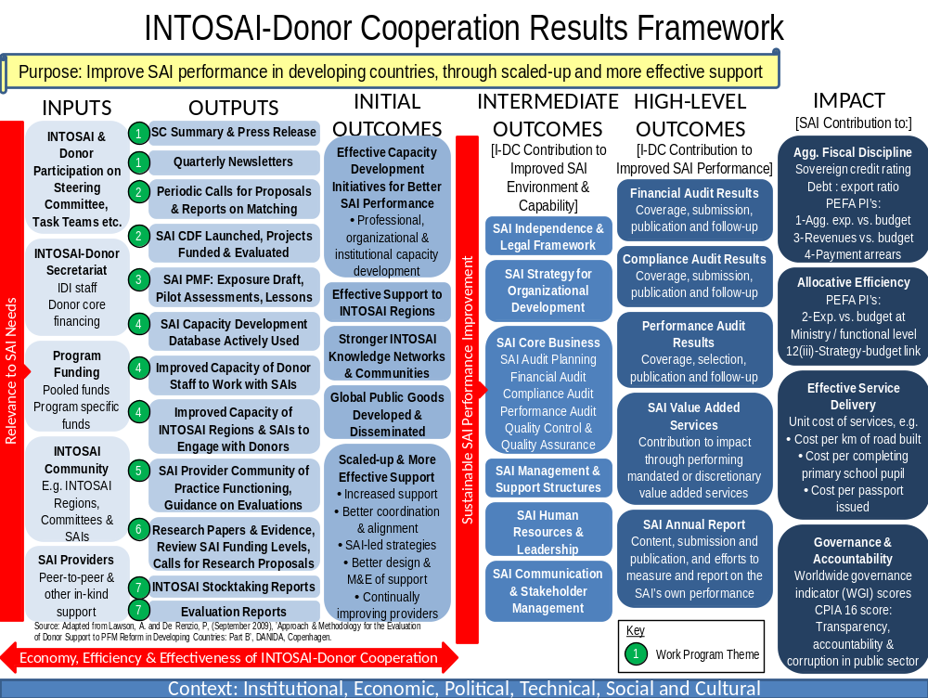
Note: ‘Work Program Theme’ relates to the seven themes agreed in the 2013-15 program document.

Financial and Other Support for the INTOSAI-Donor Cooperation (Phase 2)

IDI, as host of the Secretariat, entered into a Program Contract regarding funding for the INTOSAI-Donor Cooperation 2013-15, with the Austrian Development Agency (ADA) and Ministry of Foreign Affairs and Trade, Ireland, in December 2012. During 2013, the Norwegian Agency for Development Cooperation (NORAD) and the State Secretariat for Economic Affairs (SECO) (Switzerland) each signed an Addendum to the Program Contract. The Program Contract contains, as Annex 1, an agreed program summary consistent with the PD. The Department for International Development (DFID) (UK) has expanded an existing accountable grant arrangement to include a component to support the Cooperation, to which the PD is an annex.
The World Bank has provided support to theme 3 (SAI PMF) as part of its ISSAI Implementation Initiative grant, which is covered by separate reporting arrangements. The Office of the Auditor General of Norway (OAGN) provides a rolling 12 month secondee under an informal arrangement, and the TCU Brazil provides one staff member on a half-time basis under a memorandum of understanding between IDI and the TCU. There are no formal reporting requirements under these arrangements.
Other in-kind support (e.g. translations, hosting workshops, providing facilitators, support in developing SAI PMF video, participating in task teams) was received during 2013 from the SAIs of: Brazil, Canada, Chile, China, Cook Islands, Cyprus, France, Germany, India, Morocco, Norway, Peru, Poland, Russia, Saudi Arabia, Slovak Republic, South Africa, Sweden, Tunisia, UK, and USA; from the INTOSAI regional bodies CREFIAF, AFROSAI-E, ARABOSAI, EUROSAI, and OLACEFS; and from the Inter American Development Bank, World Bank, and Canadian Comprehensive Audit Foundation.
The Program Contract stipulates that there will be an Annual Donor Meeting in order to discuss the progress of the program and the cooperation between the funding Donors. Wherever possible, the Annual Donor Meeting should be organized together with the regular SC Meetings. The 2013 Annual meeting was held on 20th October 2013, in connection with the 6th SC meeting in Beijing, and attended by IDI, NORAD, Irish Aid and DFID.
Section 6 of the Program Contract outlines the reporting requirements, consisting of an annual narrative report, accompanied by IDI’s audited financial statements, IDI’s ordinary annual financial audit report and any management letters provided by the auditor. These documents are to be submitted to the Donors by 31 May each year.
Paragraph 6.3.2 states that the narrative report shall include the following:
- An assessment of the progress of the implementation of the programme, including achieved results (output and outcome), compared to the Agreed Programme Summary,
- an explanation of major deviations from the plan (if applicable),
- an assessment of the management of internal or external risks to the Project that may affect the success of the Project,
- an assessment of the need for adjustments to agreed plans, including actions for risk mitigation,
- a brief summary of the use of funds compared to budget.

The following constitutes the performance and financial report for 2013. There are five annexes to the report, namely: Annex A: INTOSAI-Donor Cooperation Logframe, as at 31 December, 2013, Annex B: Signed English Financial Statements for IDI 2013, Annex C: English notes to Financial Statements for IDI 2013, Annex D: Signed Norwegian Auditors Report for IDI 2013, Annex E: Translated English Auditors Report for IDI 2013.

INTOSAI-Donor Cooperation Governance Arrangements

The MoU establishes the governance structure of the Cooperation, consisting of the SC as the decision making body, assisted by the Secretariat that provides administrative support. The inaugural SC Meeting in 2010 decided to locate the Secretariat as an integral part of the INTOSAI Development Initiative (IDI) in Oslo, Norway. The full governance arrangements for the INTOSAI-Donor Cooperation are articulated in the PD. The following summarises the functioning of the main governance bodies during 2013.

Steering Committee
The SC held its 6th meeting on 18-19th October 2013 in Beijing, immediately before the XXI INTOSAI Congress. The meeting reviewed progress against the 2013 work program, made decisions on key agenda items, and approved the work plan for 2014. The key summary points and press release from the meeting are available at http://www.idi.no/artikkel.aspx?MId1=137&AId=982.

Steering Committee Leadership
The SC leadership comprises the INTOSAI and Donor chairs and vice chairs of the SC, supported by the Secretariat. It provides strategic direction and interim decision making on behalf of the SC between SC meetings. During 2013 it met by teleconference six times, approximately every second month (January, March, May, July, September and December). Summaries of the SC leadership teleconferences were shared with the IDI Board and donors to the Secretariat, as per the agreed governance arrangements.

INTOSAI-Donor Secretariat
The Secretariat is a department within IDI, whose financial activities are separately identifiable within IDI’s financial statements, in order to meet donor requirements in the Program Contract. During 2013 the Secretariat was staffed as follows:
Position | Title | Comments
0,5 | Head of Secretariat / Deputy Director General IDI | The head of the Secretariat works 50 % for the INTOSAI-Donor Secretariat and 50 % for the IDI as Deputy Director General for administration and stakeholder relations. 50 % of his salary costs are covered over the INTOSAI-Donor Secretariat budget.
1 | Advisor (International) | Salary costs covered by the INTOSAI-Donor Secretariat budget.
1 | Advisor (international) | Salary costs covered by the INTOSAI-Donor Secretariat budget.
1 | Advisor (Norwegian) | Salary costs covered by the INTOSAI-Donor Secretariat budget.
1 | Advisor (OAGN secondee) | Salary costs covered by the Office of the Auditor General of Norway.
0,5 | Advisor (TCU Brazil secondee) | Salary costs covered by TCU Brazil

The total number of positions was 5, of which 3,5 positions were financed from the Secretariat’s budget. The head of the Secretariat is also head of administration and stakeholder relations in the IDI and the salary is funded 50 % from the Secretariat’s funds and 50 % from core IDI funds. The dual responsibility enables exploitation of synergies and more effective coordination and information sharing between the INTOSAI-Donor Cooperation and the IDI program activities. The Office of the Auditor General of Norway offers a secondment in the Secretariat for one of their staff each year on a rolling basis, and they cover the salary cost of the secondee. TCU Brazil similarly provided one member of staff, on a half time basis. In addition, the Secretariat benefits from the support services provided by IDI’s administration department, and pays a fair share of the costs of IDI’s administration and overheads.

The expected staffing for the remainder of the period 2013-15 is discussed in section 3.6.

INTOSAI-Donor Cooperation Performance Report, 2013

Levels of Results Reporting
The INTOSAI-Donor Cooperation exists to achieve the objectives of the MoU between the INTOSAI and the donor communities, namely to improve the performance of SAIs in developing countries, through scaled-up and more effective support provided by the INTOSAI and donor communities. Carrying out this work will help towards the goal of making the lives of citizens better in all developing countries through improving Public Financial Management, strengthening fiscal accountability and transparency, contributing to better public sector governance, and tackling corruption.
It is the responsibility of SAIs in developing countries to continuously improve their performance. The Cooperation contributes to and facilitates these efforts. Even though SAI performance may not be solely and directly attributable to the work of the Cooperation, it is essential to measure and monitor against the program purpose.
The expected results attributable to the Cooperation are at the initial outcome level, grouped under the following areas.
- Effective capacity development initiatives for better SAI performance
- Effective support to INTOSAI regions
- Stronger INTOSAI knowledge networks and communities
- Global public goods developed and disseminated
- Scaled-up and more effective support
These are longer term results, with the first target milestone for the Cooperation being at the end of 2014. Where feasible, early indications are given towards achievement of these milestones, based on evidence and observations from monitoring the seven themes, as at 31 December 2014.
The main monitoring of performance of the Cooperation is structured according to the seven themes of the PD, utilising indicators from the Cooperation Logframe, and progress against the annual work plan.
Therefore the INTOSAI-Donor Cooperation performance reporting is at three levels:
  - Reporting against the program purpose (high-level outcomes in the results framework): has performance of SAIs in developing countries improved?
  - Reporting against expected results attributable to the Cooperation (initial outcomes in the results framework): has the INTOSAI-Donor Cooperation improved the effectiveness and increased the volume of capacity development support to SAIs in developing countries?
  - Reporting progress against the work program themes (outputs in the results framework and progress against the 2013 work plan): were the planned outputs and activities of the INTOSAI-Donor Cooperation for 2013 achieved?

Reporting Against Program Purpose: Improved SAI Performance in Developing Countries
The following summarises performance against the three high level indicators in the Logframe. For a more detailed analysis of changes in the performance of SAIs in developing countries, see the INTOSAI-Donor Secretariat: Narrative Report 2012 and Final Report 2010-12. Updated analysis in this area will also be included within the IDI Global Survey report 2014.
High-Level Outcome Indicator: H1 | Baseline 2010 | Milestone 1 2014 | Milestone 2 2016 | Target 2018 | Progress
Percentage of SAIs in developing countries (for which a PEFA assessment is available) scoring a C or higher on PEFA PI-26 ‘Scope, Nature and Follow-up of External Audit’ | LDC & LI = 26%  LMI = 33%  UMI = 60% | LDC & LI = 30%  LMI = 40%  UMI = 70% | LDC & LI = 40%  LMI = 50%  UMI = 80% | LDC & LI = 50%  LMI = 60%  UMI = 90% | 2014 milestones reached already in LDCs/Lis and LMIs, but global decline in UMIs
 | Achieved: | LDC & LI = 38%  LMI = 46%  UMI = 54%
 | Source: INTOSAI-Donor Secretariat review of latest indicator scores on the full PEFA database (including unpublished assessments)
Comparing the latest available PEFA data (December 2013) to the May 2010 baseline demonstrates a global increase in levels of SAI performance. Specifically, it shows an increase in the proportion of countries scoring a C or higher on their latest PEFA indicator, meaning all the following conditions are in place in relation to the external audit system:
- Central government entities representing at least 50% of total expenditure are audited annually
- Audits identify significant issues
- There is some disclosure regarding the nature of the audit standards used
- Audit reports are submitted to the legislature within 12 months of the end of the period covered (and for financial audits, within 12 months from the receipt of financial statements by the SAI)
- A formal response is made (by the executive) to audit reports (though it may be delayed or not very thorough)

Regarding UMIs, the percentage of countries scoring a C or higher has declined from 60% to 54%. Closer examination reveals that in the December 2013 data, the additional 12 UMIs in the population includes six small island states, all of which score D or D+, as well as a further three countries entering the data for the first time, which all score D+. The decline in this indicator appears therefore to be attributable to the change in the population, rather than to declines in performance within UMI countries.

High-Level Outcome Indicator: H2 | Baseline 2010 | Milestone 1 2014 | Milestone 2 2016 | Target 2018 | Progress
Percentage of SAIs in developing countries that issue their annual audit reports within the established legal time frame | LDC & LI = 70%  LMI = 77%  UMI = 80% | LDC & LI = 70%  LMI = 80%  UMI = 80% | LDC & LI = 75%  LMI = 85%  UMI = 85% | LDC & LI = 80%  LMI = 90%  UMI = 90% | 2014 milestones reached already in LMIs & UMIs, but decline in LDCs/LIs
 | Achieved: | LDC & LI = 54%  LMI = 90%  UMI = 81%
 | Source: IDI Global Survey (draft)
Results from the IDI Global Survey shows, for lower-middle income countries, an increase in the percentage of SAIs issuing their audit reports (to Parliament or other relevant body) within the established legal frameworks. For upper-middle income countries, there was no change. For the low income country group, there has been a significant decline in performance here. The figures are based on 30 respondents in 2010 and 28 respondents in 2013 (excluding those answering ‘other’). While the populations between the two samples have changed, there are still 20 SAIs that answered this survey question in both years. Holding the population constant in this case does confirm that there has been a decline in the timely issuance of annual reports among low income countries. Specifically, four countries reporting timely submission in 2010 now report late submission in 2013. It is notable one of these countries experienced a Coup and another a major period of civil unrest. However, what is more worrying is that no low income countries that reported late submission in 2010 have reported timely submission in 2013.
In total, almost half of SAIs in low income countries still do not issue their annual reports within the legal timeframes. Considerable effort is required, at a country level, to better understand the reasons for this, and support appropriate action by all stakeholders.
Analysis of the raw data also highlights several countries which either have no legal requirement to issue an annual audit report, or no established legal time frame in which to do so.
High-Level Outcome Indicator: H3 | Baseline 2012 | Milestone 1 2014 | Milestone 2 2016 | Target 2018 | Progress
Percentage of SAIs in developing countries (for which a PEFA assessment is publicly available) in which all external audit reports on central government consolidated operations are made available to the public through appropriate means within six months of completed audit. | LDC & LI = 35%  LMI = 62%  UMI = 78% | LDC & LI = 40%  LMI = 70%  UMI = 80% | LDC & LI = 50%  LMI = 75%  UMI = 85% | LDC & LI = 60%  LMI = 80%  UMI = 90% | 2014 milestone exceeded already in all income groups
 | Achieved: | LDC & LI = 44%  LMI = 74%  UMI = 81% |  |  | 2014 milestone exceeded already in all income groups
 | Source: INTOSAI-Donor Secretariat review of latest published PEFA reports (PEFA PI-10, criteria (iv)) |  |  |  | 2014 milestone exceeded already in all income groups
Regarding timely publication of audit reports, there has been strong progress from the 2012 baseline in all income groups, and good overall performance in middle income countries. However, it is notable that less than half of low income countries publish their principal external audit report in a timely manner. Non-publication of audit reports is usually (though not always) a result of inadequate legal framework which empowers and requires the SAI to publish its reports, and/or interference from external agents which prevents or dissuades the SAI from publishing. Clearly further work is needed in low income countries to create appropriate environments in which the SAI report can be published.

Reporting Against Expected Results: Scaled-up and More Effective Support
The following summarises results (at the initial outcome level) and progress on efforts to scale up and improve the effectivess of support to SAIs in developing countries, according to the five initial outcomes in the INTOSAI-Donor Cooperation results framework.

Effective Capacity Development Initiatives for Better SAI Performance
The Secretariat had no plans to collect data in this area during 2013. Regarding initiatives taken forward under the Cooperation, specifically projects from the initial round of matching in 2010 and the 2011 Global Call, data should be collected as part of the work on synthesis of SAI capacity development initiatives during 2014. The forthcoming evaluation of the INTOSAI-Donor Cooperation will also look at this for a small number of country case studies.

Effective Support to INTOSAI Regions
The Cooperation has been successful in supporting and strengthening the INTOSAI regional and sub-regional bodies. The initial matching of proposals in 2010 and the 2011 global call both led to significant support for the INTOSAI regions, so that all the regions except CAROSAI and EUROSAI currently have external support for their core functions to enable delivery of capacity development initiatives. EUROSAI operates rather as a network for sharing information and has not sought external support.

The Cooperation has specifically sought to strengthen the skills of the regions in two areas: SAI PMF and developing needs based funding applications. All eight regions/sub-regions now have at least one SAI PMF trained trainer, five regions have staff who have already delivered SAI PMF training, and seven regions have at least three SAI PMF assessors. Training on developing needs based funding applications was offered to all regions, and based on demand, delivered in ARABOSAI, CREFIAF and OLACEFS. All these regions now have staff available to support SAIs in their regions. However, no staff were identified who could deliver this training in future.

Stronger INTOSAI Knowledge Networks and Communities
The PD identifies three main knowledge networks to be established under the Cooperation: SAI PMF, developing needs based funding applications, and the Supply Side Community of Practice. The SAI PMF network had over 220 members including 20 who had also delivered the training by the end of 2013. The Secretariat plans to develop support networks to better enable this community to interact and share experiences through a SAI PMF community portal in late 2014. The network on developing needs based funding applications had over 80 participants by the end of 2013, many of whom have been further developing their skills through drafting concept notes under the global call for proposals.

The supply side community of practice was not established, following decision at the 6th SC meeting.

Global Public Goods Developed and Disseminated
The Secretariat’s main work in this area has been development and dissemination of the SAI PMF. It was approved and published in July 2013, and dissemination included eight one-week training courses across the world, as well as numerous shorter awareness raising activities. Work on another global public good, guidance on better evaluations of SAI capacity development projects, also commenced in 2013.

Members of the Cooperation have led or supported several other global public goods which have been published during 2013, including:
- Extractive Industries Audit: The Role of Supreme Audit Institutions (IDI and AFROSAI-E)
- Supreme Audit Institutions – Accountability for Development (GIZ)
- Citizen Engagement Practices by Supreme Audit Institutions (UNDESA and INTOSAI)

Two further global public goods were under development at the end of 2013, “Citizen Engagement and Supreme Audit Institutions: Stock Taking Report” (OECD), and “Exploring Results of SAI Reforms” (Inter American Development Bank).

Scaled-up and more effective support
Scaled-up Support
Outcome Indicator I5.1 | Baseline 2012 | Milestone 1 2014 | Milestone 2 2016 | Target 2018 | Progress
Moving three year average annual financial support for the benefit of SAIs in ODA eligible countries | US $41 million | US $55 million | US $70 million | US $80 million | The increase from 2012 baseline suggests the target may just be met.
 | Achieved: | US $48 million
 | Source: Secretariat calculations extracted from SAI Capacity Development Database

The Cooperation is intended to lead to scaling-up support for SAI capacity development. To ensure this is happening, rather than the same funds being channelled differently, the Secretariat makes use of the SAI Capacity Development Database to monitor the total global value of capacity development support for SAIs. This has increased from US $41 million in 2012 to $48 million in 2013, and looks on track to reach the 2014 milestone. The SAI Capacity Development Fund (SAI CDF) is also intended to contribute to this scaling-up. At the end of 2013, SECO had pledged 5 million Swiss Francs (around US $5.6 million), but the agreements had not yet been signed.

SAI-led Strategies and Coordination and Alignment of Support

Outcome Indicator I5.4 | Baseline 2010 | Milestone 1 2014 | Milestone 2 2016 | Target 2018 | Progress
Percentage of SAIs with a strategic plan and development action / operational plan currently in place | Strategic Plan:  LDC & LI = 63%  LMI = 84%  UMI = 71%  Development Action Plan:  LDC & LI = 38%  LMI = 62%  UMI = 53% | Strategic Plan:  LDC & LI = 70%  LMI = 90%  UMI = 80%  Development Action Plan:  LDC & LI = 45%  LMI = 65%  UMI = 60% | Strategic Plan:  LDC & LI = 80%  LMI = 90%  UMI = 80%  Development Action Plan:  LDC & LI = 60%  LMI = 75%  UMI = 75% | Strategic Plan:  LDC & LI = 90%  LMI = 90%  UMI = 90%  Development Action Plan:  LDC & LI = 75%  LMI = 90%  UMI = 90% | 2018 targets already achieved for strategic plans and development action plans in all income groups.
 | Achieved: | Strategic Plan:  LDC & LI = 98%  LMI = 89%  UMI = 95%  Development Action Plan:  LDC & LI = 88%  LMI = 100%  UMI = 98%
 | Source: IDI Global Survey (draft)
SAI-led strategic plans and development action plans are essential for effective capacity development, and a key principle of the Cooperation. This has been a priority of the Cooperation since signing of the MoU, and the subject of a number of IDI programs, including those prioritised from the first round of matching in 2010. This indicator is approaching 100% in some areas, with just a few countries in CREFIAF and some new SAIs, such as Tajikistan, not yet having strategic plans in place.
The Cooperation also seeks to ensure support for SAI capacity development is aligned behind country-led plans, and coordinated among donors. The SAI capacity development database should make such coordination easier through better sharing of information, and these principles are firmly embedded in the global call for proposals. Responses from the 2013 global survey suggest that (for responding SAIs) in over 90% of countries, all support is aligned with the SAI’s strategic plan. While this is encouraging, it is important that such survey data is triangulated with independence assessments, such as in the forthcoming Evaluation of the INTOSAI-Donor Cooperation.

Regarding initiatives taken forward under the Cooperation, specifically projects from the initial round of matching in 2010 and the 2011 Global Call, further data should be collected as part of the work on synthesis of SAI capacity development initiatives. The forthcoming evaluation will look at these areas for a small number of country case studies.

Better Design, Monitoring and Evaluation of Support

The training for donors on working with SAIs is intended to contribute to better design of SAI capacity development projects, though delivery of this course will now only commence in 2014. The use of peer review at program design phase, and inclusion of meaningful results frameworks, is also intended to lead to better designed programs. The SAI PMF is now being used by a number of SAIs to develop indicators for capacity development projects, set baselines and measure improvement.

Regarding initiatives taken forward under the Cooperation, specifically projects from the initial round of matching in 2010 and the 2011 Global Call, data should be collected as part of the work on synthesis of SAI capacity development initiatives. This should also look at the use of external evaluations of large projects. The forthcoming evaluation of the INTOSAI-Donor Cooperation will also look at these areas for a small number of country case studies.

Continually Improving Providers of Support

Scaling-up support, improving ownership, alignment and harmonisation, and improving the design of support will only be effective in enhancing SAI performance if the quality of support provided is satisfactory. The PD proposes efforts to enhance the provision of support to SAIs, noting common deficiencies in the current provision of support. In accordance with the decision at the 6th SC meeting, no activities have been taken forward in this area.

Reporting Progress against the Work Program Themes
The INTOSAI-Donor Cooperation Logframe is included as Annex A, updated to show actual achievement against milestones as at 31 December 2013. Selected extracts from the Logframe are shown under each theme below, but for comprehensive monitoring against all expected results, please refer to the Logframe.

The 2013 work plan was adopted at the 5th INTOSAI-Donor Steering Committee Meeting, London, October 2012, showing planned activities by theme. Progress against the work plan activities by the end of 2013 is shown under each theme below.

Theme 1: INTOSAI-Donor Cooperation Management
Output Indicator O1.2 | Baseline 2012 | Milestone 1 2013 | Milestone 2 2014 | Target 2015 | Progress
No. of quarterly news letters issued per year | 4 | 4 | 4 | 4 | Milestone achieved
No. of quarterly news letters issued per year | Achieved: | 4 |  |  | Milestone achieved
No. of quarterly news letters issued per year | Source: Quarterly newsletters |  |  |  | Milestone achieved

No. | Theme and Task | Priority for 2013 | Responsibility | Progress
1 | INTOSAI-Donor Cooperation Management
1.1 | Facilitate SC meeting and SC leadership teleconferences | High | Secretariat | Completed
1.2 | Communication and outreach on INTOSAI-Donor Cooperation (including newsletters) | High | Secretariat | Completed
The Secretariat facilitated the 6th Steering Committee meeting in Beijing, 18-19th October, attended by a record 76 participants, as well as six teleconferences of the SC leadership throughout the year.
In addition to issuing four quarterly newsletters on the INTOSAI-Donor Cooperation during 2013, Secretariat staff presented at four global & regional conferences: Connecting Voices, UN-INTOSAI symposium, ICGFM conference, and CReCER.

Theme 2: Funding Mechanisms and Project Identification
Output Indicator O2.2 | Baseline 2012 | Milestone 1 2013 | Milestone 2 2014 | Target 2015 | Progress
No. of global calls for proposals for SAI capacity development initiatives issued per year  (SP goal 1.1) | 0 | 1 | 0 | 1 | Milestone achieved. SC agreed to move to biannual, hence no global call now planned for 2014
 | Achieved: | 1
 | Source: Progress reports on the global call for proposals

No. | Theme and Task | Priority for 2013 | Responsibility | Progress
2 | Funding Mechanisms and Project Identification
2.1 | Secure pledges for and establish SAI Capacity Development Fund | High | Donors and Secretariat | Pledge from SECO, work was in progress to agree administrative arrangements and sign contract (done 2014)
2.2 | Launch 2nd Global Call for Proposals | High | Secretariat | Done at 6th SC meeting
2.3 | Prepare and submit concept notes | High | INTOSAI applicants, Secretariat | Completed
2.4 | For those concept notes where Capacity Development Fund or individual donors have indicated possible support, develop full proposals | High | INTOSAI applicants, World Bank, Secretariat | Ongoing in 2014
During 2013, work continued on establishment of the SAI CDF, with a major break through as SECO and the World Bank agreed to establish a Trust Fund with a single initial donor, and the intention for others to join in future. The SAI CDF was not established by the year end, but everything was in place and it was formally signed in early 2014. There are positive indications of additional donors planning to join during 2014-15.
The global call for proposals was redesigned to include an initial concept note stage, to reduce potentially abortive work for applicants, and launched at the 6th SC meeting in Beijing. Draft applications were due by 31 January 2014 for review by the Secretariat. The guidance and application templates were made available in English, Arabic, French, Spanish, Portuguese and Russian.

Theme 3: SAI Performance Measurement Framework
Outcome Indicator I2.1 | Baseline 2012 | Milestone 1 2014 | Milestone 2 2016 | Target 2018 | Progress
Number of INTOSAI regional / sub-regional bodies with access to the following number of staff / experts trained on SAI PMF:  - At least three trained SAI PMF assessors  - At least one trained SAI PMF trainer  (IDI SP goals 1.2 and 3.2) | Regions with assessors: 0  Regions with trainers: 0 | Regions with assessors: 6  Regions with trainers: 6 | Regions with assessors: 8  Regions with trainers: 8 | Regions with assessors: 8  Regions with trainers: 8 | Already ahead of 2014 milestone, following completion of 8 training courses in 6 regions in 2013 & strong participation of SAIs.
 | Achieved | Regions with assessors: 7  Regions with trainers: 8
 | Source: Secretariat lists of trained SAI PMF trainers and assessors
Outcome Indicator I3.1 | Baseline 2012 | Milestone 1 2014 | Milestone 2 2016 | Target 2018 | Progress
No. of people trained on the SAI PMF as assessors and trainers:  - INTOSAI assessors  - INTOSAI trainers  - Donor assessors  - Donor trainers  - Consultant assessors  - Consultant trainers  (IDI SP goals 1.2 and 3.2) | Male & Female  - 0 & 0  - 0 & 0  - 0 & 0  - 0 & 0  - 0 & 0  - 0 & 0 | Male & Female  - 50 & 50  - 2 & 2  - 10 & 10  - 2 & 2  - 5 & 5  - 2 & 2 | Male & Female  - 75 & 75  - 5 & 5  - 20 & 20  - 5 & 5  - 10 & 10  - 5 & 5 | Male & Female  - 100 & 100  - 5 & 5  - 30 & 30  - 5 & 5  - 10 & 10  - 5 & 5 | Already ahead of most 2014 milestones, following completion of 8 training courses in 2013 and use of trained experts as co-facilitators on further courses.
 | Achieved: | Male & Female  - 113 & 55  - 9 & 8  - 22 & 16  - 1 & 0  - 11 & 3  - 2 & 0
 | Source: Secretariat lists of trained SAI PMF trainers and assessors
Outcome Indicator I4.1 | Baseline 2012 | Milestone 1 2014 | Milestone 2 2016 | Target 2018 | Progress
Development, dissemination and usage of versions of the SAI Performance Measurement Framework:  - Status of development and dissemination of SAI PMF  - Number of countries in which the current version of SAI PMF has been piloted/applied  (IDI SP goals 1.2 and 2.1) | Version 2 published  Pilots in 3 countries | Exposure draft published  20 pilots in total | Final SAI PMF approved by INTOSAI  30 pilots in total | Final SAI PMF applied in further 20 countries | Interest in SAI PMF pilots suggests the milestone will be met.
 | Achieved: | Pilot version published  7 pilots started / approved
 | Source: Secretariat records of SAI PMF pilots
Output Indicator O3.2 | Baseline 2012 | Milestone 1 2013 | Milestone 2 2014 | Target 2015 | Progress
No. of regional training courses run for trainers and assessors | Not started | Training for assessors run in 8 regions  One course run to train trainers | Training for assessors run in 4 regions | Training for assessors run in 4 regions | 8 training courses run as planned, but course in PASAI scheduled for Q1 2014 and no course yet requested in AFROSAI-E.
 | Achieved: | 8 combined training courses for assessors & trainers run in 6 regions
 | Source: Secretariat annual progress reports
Output Indicator O3.3 | Baseline 2012 | Milestone 1 2013 | Milestone 2 2014 | Target 2015 | Progress
Support provided to SAI PMF pilot assessments from the Secretariat:  - Percentage of ToRs reviewed  - Percentage of draft reports reviewed  (IDI SP goal 2.1) | ToRs: N/A  Reports: N/A | ToRs: 50%  Reports: 80% | ToRs: 70%  Reports: 85% | ToRs: 80%  Reports: 90% | Current figures suggest milestone met, but inclusion of assessments where little information received may put this indicator off-track.
 | Achieved: | ToRs: 86%  Reports: 80%
 | Source: Secretariat annual progress reports

No. | Theme and Task | Priority for 2013 | Responsibility | Progress
3 | SAI Performance Measurement Framework
3.1 | Exposure draft SAI PMF published on WGVBS website | High | SAI PMF Task Team | Completed
3.2 | Training courses for assessors run in all INTOSAI regions | High | SAI PMF Task Team | Courses run in 6 regions in 2013 and remaining 2 regions planned for Q1 2014
3.3 | Phase 2 pilots in progress | High | SAIs, INTOSAI bodies, donors | Phase 2 piloting launched and 7 SAIs had begun pilots by end December, with more considering pilots.
3.4 | Exposure draft SAI PMF presented at 6th SC meeting and INCOSAI XXI | High | SAI PMF Task Team | Completed
Following initial tests of the SAI PMF (version 2.0) in three countries in Q4 2012, and global consultation, the SAI PMF task team met in South Africa in January to begin revision of the SAI PMF. The SAI PMF pilot version was approved (for further piloting) by the WGVBS at its meeting in July and published on 12th July.
The SAI PMF roll-out strategy began with development of training material and initial training courses for potential future trainers in Oslo in March, based on working versions of the SAI PMF. Initial courses in English enabled training of trainers that could deliver the course in other languages. During 2013, eight courses were held in Oslo, London, Miami, Lima, Tunis, Warsaw, Delhi and Marrakesh, delivered in English, French and Spanish. These were held in 6 INTOSAI regions, but participants attended from all regions, so that all regions now have a trained SAI PMF trainer. By the end of 2013, there were 229 people trained on SAI PMF, and 20 people experienced in delivering SAI PMF training.
By the end of 2013, the Secretariat was aware of seven countries that had started or formally approved SAI PMF assessments, and many more considering doing so. Over 80% of the ToRs and draft reports were shared with the Secretariat for quality assurance review – however it is likely that these figures will drop once other assessments, which the Secretariat is less closely involved in, are included.

Theme 4: Knowledge Centre on Support to SAIs
Outcome Indicator: I2.2 | Baseline 2012 | Milestone 1 2014 | Milestone 2 2016 | Target 2018 | Progress
Number of INTOSAI regional / sub-regional bodies with the following number of staff / experts trained on engagement with donors and writing funding proposals:  - At least three staff / experts able to advise SAIs on the subject  - At least one facilitator trained to deliver the training  (IDI SP goal 3.2) | Regions with advisors: 1  Regions with facilitators: 0 | Regions with advisors: 3  Regions with facilitators: 3 | Regions with advisors: 6  Regions with facilitators: 6 | Regions with advisors: 6  Regions with facilitators: 6 | Based on demand, training run in 3 regions. Suitable experts to act as facilitators not identified so far.
 | Achieved: | Regions with advisors: 3  Regions with facilitators: 0
 | Source: Secretariat lists of regional advisors and facilitators completing, and used to deliver, training on engagement with donors and writing funding proposals
Outcome Indicator: I3.2 | Baseline 2012 | Milestone 1 2014 | Milestone 2 2016 | Target 2018 | Progress
No. of INTOSAI staff in community of experts on engagement with donors and writing funding applications:  - Subject matter experts (SMEs) (completed training)  - Facilitators (trained to deliver training)  (IDI SP goal 3.2) | Male & Female  SMEs: 21 & 5  Facilitators: 0 & 0 | Male & Female  SMEs: 30 & 30  Facilitators: 3 & 3 | Male & Female  SMEs: 50 & 50  Facilitators: 6 & 6 | Male & Female  SMEs: 60 & 60  Facilitators: 9 & 9 | SMEs on track but few experts available to act as facilitators. Will need training & experience prior to becoming facilitators.
 | Achieved: | Male & Female  SMEs: 63 & 18  Facilitators: 0 & 1
 | Source: Secretariat lists of INTOSAI advisors and facilitators completing, and used to deliver, training on engagement with donors and writing funding proposals
Output Indicator O4.2 | Baseline 2012 | Milestone 1 2013 | Milestone 2 2014 | Target 2015 | Progress
Development and delivery of training for donor staff on working with SAIs  (IDI SP goal 3.2) | Not started | Course developed & piloted once | Course refined and repeated once | Course delivered once | Development on track, first pilot delayed due to events in Egypt (planned location of first course).
 | Achieved: | Course developed, pilot Q1 2014
 | Source: Secretariat annual progress reports

No. | Theme and Task | Priority for 2013 | Responsibility | Progress
4 | Knowledge Centre on Support to SAIs
4.1 | Maintenance of SAI capacity development database | High | Secretariat | 2 updates of the database in 2013
4.2 | Disseminate public goods, support to donor engagement with SAIs, represent INTOSAI in development fora | Medium | Secretariat | Continuous
4.3 | Training for donors on working with SAIs  - Training material drafted  - Pilot training course completed  - Proposal for roll-out completed | Medium | Secretariat | - Completed  - Cancelled  - Delayed
4.4 | Training for SAIs on engagement with donors and writing funding applications | Medium | Secretariat | 3 courses delivered on request
The Secretariat continues to maintain the SAI capacity development database, and oversaw two updates of the database in 2013. The SAI capacity development database advisory committee met by teleconference in May 2013. By end December 2013, the database held records of 287 SAI capacity development programs, and is used actively by SAIs and donors to improve the coordination of support to SAIs.
Based on a decision by the INTOSAI Governing Board, the IDI, together with the Chair of the CBC, continues to serves as the focal point for INTOSAI’s engagement with the broader development community. In 2013, CBC and IDI took forward engagement with the OECD and other development partners, including close cooperation with OECD and a number of SAIs on a stock take of citizen engagement in SAIs. In 2013 IDI also responded to numerous inquiries from the development community, for example presenting on the Cooperation to Irish Aid, running Brown Bag lunches for the World Bank, and providing advice to DFID country offices.

During 2013, the Secretariat developed a training course for donor staff on working with SAIs, together with the UK NAO and French Cour des Comptes. This was planned to be delivered in late 2013 in Egypt for USAID staff, but unfortunately had to be cancelled due to worsening security situation there. This also meant that the proposal for future roll-out could not be completed. The course has since been run during Q1 2014 in Washington for a multi-donor group.

To improve the quality of applications under the global call for proposals, the Secretariat offered training to all INTOSAI regions. Training was requested and delivered in OLACEFS (in Spanish), ARABOSAI (in Arabic), and CREFIAF (in French). Training was initially also requested in EUROSAI, but due to the low number of course registrants, this course was cancelled. Sufficient numbers of SAI staff were trained, and staff of the relevant INTOSAI regional bodies attended so they could provide advice to SAIs in their regions when developing concept notes under the global call. However, the Secretariat did not find suitable experts among those trained that would be able to help deliver such a course in future, as many of the concepts and skills were quite new to the participants. SAI staff will need to gain more practical experience in this area, through developing their SAI’s concept notes and helping manage resulting projects, before they can help transfer these skills on to others.

Theme 5: Strengthening the Supply of Support to SAIs
Output Indicator O5.3 | Baseline 2012 | Milestone 1 2013 | Milestone 2 2014 | Target 2015 | Progress
Development and dissemination of guidance on evaluations of SAI capacity development initiatives  (IDI SP goal 1.2) | Not started | ToRs approved and work started | Guidance published | N/A | On track, but detailed plan is to develop in 2014 and pilot in 2015, before publishing.
 | Achieved: | ToRs approved and work started
 | Source: Secretariat annual progress reports

No. | Theme and Task | Priority for 2013 | Responsibility | Progress
5 | Strengthening the Supply of Support to SAIs
5.1 | - Establish SAI Supply Side Community of Practice  - Hold first technical update | Medium | Secretariat | SC decision at 6th SC meeting NOT to establish CoP at this stage
5.2 | Develop guidance on better evaluations of SAI capacity development projects  - Terms of reference approved | Medium | Secretariat, SAI Sweden & SAI Norway | Terms of reference approved
The Secretariat presented a paper to the 6th SC meeting which provided a road map to establishing a SAI supply side community of practice, as per the work plan. However, the SC questioned whether this should be a high priority activity under the Cooperation given the large number of important ongoing and planned initiatives. The SC suggested that the INTOSAI Capacity Building Committee (CBC) could be an appropriate vehicle for taking the lead on the supply side activities. It was resolved that dialogue with the CBC would continue with a view to proposing a possible way forward on the supply side activities. In addition, an analysis of challenges on the supply side would be presented at the 7th SC meeting. As a result, no technical update for a supply side community of practice was held.
The Secretariat also presented draft ToRs on developing guidance on better evaluations of SAI capacity development projects to the 6th SC meeting, and following comments after the SC meeting, these were approved. A number of SC members expressed interest in participating in this work during 2014, as part of a reference group, but no SC members volunteered to be part of the team doing the work. This work will therefore be taken forward by the Secretariat, with support from an evaluation consultant.

Theme 6: SAI Research Agenda
Output Indicator O6.1 | Baseline 2012 | Milestone 1 2013 | Milestone 2 2014 | Target 2015 | Progress
Mapping report on SAI involvement in the audit of extractive industries and engagement with EITI  (IDI SP goal 3.2) | ToRs approved and work started | Draft report submitted to SC | N/A | N/A | Work completed as planned.
 | Achieved: | Draft report submitted to SC, WG established |  |  | Work completed as planned.
 | Source: Secretariat annual progress reports |  |  |  | Work completed as planned.

No. | Theme and Task | Priority for 2013 | Responsibility | Progress
6 | SAI Research Agenda
6.1 | SAI involvement in audit of extractive industries – mapping and way forward | Low | Secretariat and AFROSAI E | Completed
6.2 | Benchmarking of SAI funding levels  - Decision on way forward (including whether to cover in possible 2013 stocktaking) | Low | Secretariat | Incorporated into the 2013 IDI Global Survey
The Secretariat’s mapping report on the audit of extractive industries was approved by the SC and published. It led to establishment of a new INTOSAI working group on the Audit of Extractive Industries, being the first time this topic has ben given such prominence within INTOSAI.
The Secretariat, working with others in IDI, agreed to include the benchmarking of SAI funding levels within the 2013 IDI Global Survey, which was issued in late 2013. A draft report is expected in mid-2014.

Theme 7: Monitoring and Evaluation
Output Indicator O7.1 | Baseline 2012 | Milestone 1 2013 | Milestone 2 2014 | Target 2015 | Progress
Update of 2010 INTOSAI Stocktaking report  (IDI SP goal 3.2) | N/A | 2013 INTOSAI stocktaking report published | N/A | N/A | Work progressing satisfactorily, but later than originally planned.
Update of 2010 INTOSAI Stocktaking report  (IDI SP goal 3.2) | Achieved: | Global survey in progress. Publish in 2014
Update of 2010 INTOSAI Stocktaking report  (IDI SP goal 3.2) | Source: Secretariat annual progress reports

No. | Theme and Task | Priority for 2013 | Responsibility | Progress
7 | Monitoring and Evaluation
7.1 | Annual progress report | High | Secretariat | Completed
7.2 | Stock taking update  - Decision on added value from possible 2013 stocktaking, and way forward | Medium | Secretariat | Incorporated into the 2013 IDI Global Survey
7.3 | External evaluation of IDI | Medium | IDI | Completed and published
The Secretariat, working with others in IDI, agreed to include the update of the 2010 INTOSAI Stocktaking within the 2013 IDI Global Survey, which was issued in late 2013. A draft report is expected in mid-2014.
The external evaluation of IDI was also completed and published. It mainly focuses on the IDI, but as part of that examines the issue of incorporation of the Secretariat within IDI. Relevant extracts from the evaluation report are summarized below.
Extracts from the 2013 External Evaluation of IDI, with Regards to the INTOSAI-Donor Secretariat

The evaluation was asked to answer the following questions regarding the organizational aspects of fully incorporating the INTOSAI-Donor Secretariat into IDI:
- What is the situation today with regard to integration?
- How is it working?
- Should the INTOSAI-Donor Secretariat be integrated more closely to IDI?
- If so, what is needed to integrate the INTOSAI-Donor Secretariat more closely to IDI?

The evaluation report noted that “The feedback from the stakeholders and INTOSAI-Donor Secretariat Leadership indicates that the stakeholders are very satisfied with the activities and results of the INTOSAI-Donor Secretariat over the past two years.” However, “An initial analysis of INTOSAI-Donor Secretariat’ plans and reporting shows that the INTOSAI-Donor Secretariat, similar to IDI, has very many and very ambitious expected results.”

With regards to hosting of the Secretariat within IDI, the evaluation concludes that “The important achievements of the INTOSAI-Donor Secretariat would not have been possible had the INTOSAI-Donor Secretariat not been part of the IDI. This is because the success of these activities depends on the participation of the SAIs, who know IDI.”

Conclusion
“Currently, the INTOSAI-Donor Secretariat is, for all practical purposes, incorporated into IDI. This is evidenced by:
- the planning, monitoring and reporting mechanisms,
- the staff, located within IDI and some working part-time with INTOSAI-Donor Secretariat and part time with IDI, and
- the achievements that have been possible also due to the IDI’s reputation among SAIs.”

Cross-Cutting Observations on Sustainability and Gender
Measures to ensure Program contributes to sustainable performance change within participating SAIs | - All activities are done in response to demand from INTOSAI bodies at the global and regional level, e.g. development of SAI PMF, training on development of funding applications, extractive industries mapping report, guidance on better evaluations.  - In particular, the Global Call for Proposals is designed to ensure and strengthen SAI ownership of future capacity development initiatives.  - Participation of individual SAIs in these activities is based on the demand of the SAI.  - Senior management of the SAIs are engaged in the various programs, e.g. Head of the SAI decides whether to conduct a SAI PMF, or apply for support under the Global Call.  - The SAI PMF is designed as a tool to measure and contribute to sustainable performance changes within an SAI.  - SAI-focused activities seek to link to and strengthen the core systems used within SAIs, so that improvements resulting from the program continue to have an impact after the activities have finished.  - Many of the activities seek to develop global public goods, develop networks of experts within the SAI community, and strengthen INTOSAI regional bodies in order to make performance changes within SAIs more sustainable.
IDI assessment of progress on sustainability measures | Most sustainability measures appear on track at this stage. Some areas to monitor are:  - Development of needs based funding applications: the capacity within INTOSAI for developing results-focused applications, and using results frameworks, appears lower than anticipated. Experience in this area suggests more needs to be done. To date, it has not been possible to start developing facilitators in the INTOSAI regions that can support member SAIs in this area.  - Improving SAI-ownership, alignment and coordination of support: this is a key part of the rationale for the INTOSAI-Donor Cooperation, which is expected to contribute to sustainability. The 2013 global survey results will give a first indication of the current situation in these areas, and help show whether there are improvements in the ‘development effectiveness’ of providers of support.
Program gender participation | 2013 monitoring (see below) suggests a gender imbalance in program participation, in regions such as ARABOSAI, OLACEFS, CREFIAF and ASOSAI, but not in EUROSAI. This reinforces the need to further emphasise the importance of gender balance when SAIs nominate participants. Standard invitation letters have been modified accordingly. To date, IDI has accepted all nominated participants therefore does not have direct control over the gender balance. Gender balance should be further monitored and reasons for the imbalance explored.  % female participants on training courses, by selected region
  Training Course | ARABOSAI | ASOSAI | CREFIAF | OLACEFS
  SAI PMF Training | 13 | 21 | 19 | 33
  Writing Funding Applications | 27 | N/A | 15 | 29

INTOSAI-Donor Cooperation: Financial Report, 2013

Budget and Initial Financing Gap, 2013-15
The budget and indicative financing for the INTOSAI-Donor Cooperation for 2013-15, as included in the PD, is summarised below. When the PD was approved, the total budget (including in-kind staff support) was 25.656 million NOK. However, based on indicative financial commitments at the time, the Cooperation faced a financing gap of 7.862 million NOK (31% of the budget).
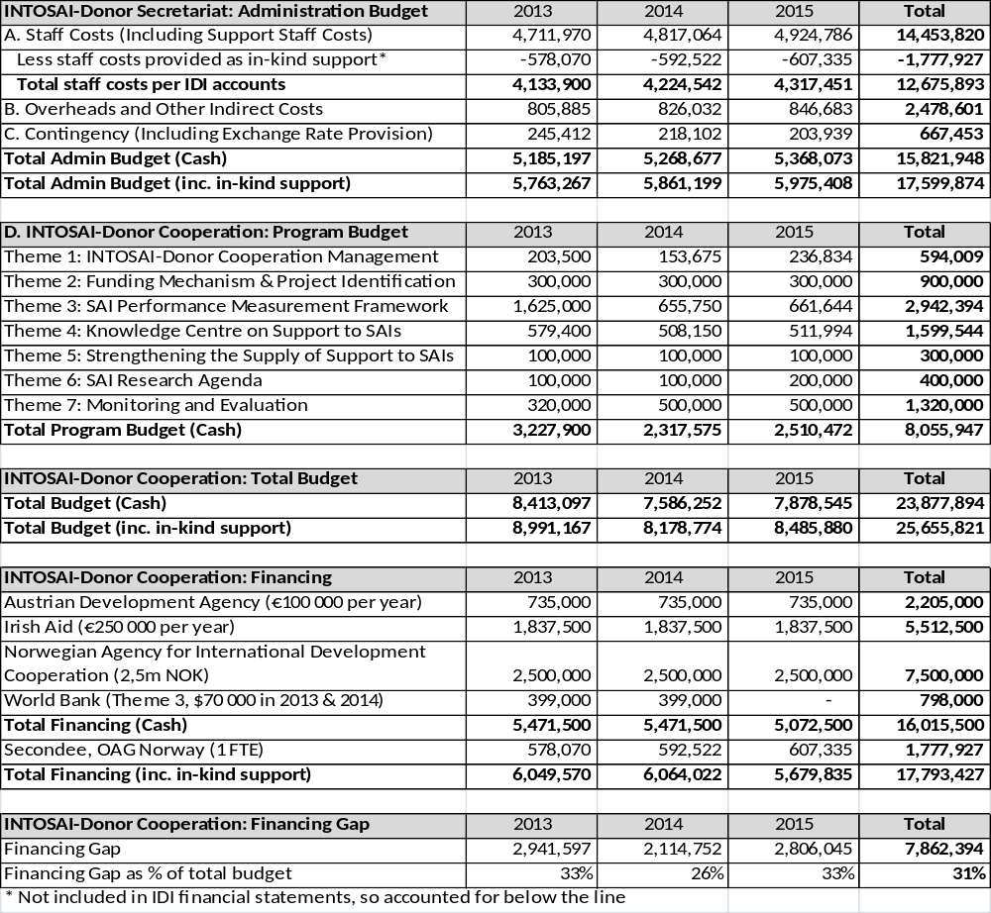All figures in Norwegian Kroner

Financing Received and Future Commitments
The following table shows the actual financing received for phase two to date, as well as estimated receipts for the remainder of phase two, based on existing commitments. DFID and SECO have entered as additional providers of core support for phase 2; MFA France has provided €100 000 for 2015; favourable exchange rate gains have increased funding from Austria and Ireland; and TCU Brazil has provided additional in-kind staff support. Support from the World Bank towards roll-out of the SAI PMF, provided as part of the ISSAI Implementation Initiative (3i) grant, has been increased following World Bank agreement to vire funds from other parts of the 3i program. An additional grant from the World Bank is also included, relating to reimbursement of additional costs for SAI PMF work in Haiti.
From 2015 onwards, core funding from Norway to the IDI, including for the INTOSAI-Donor Cooperation, will shift from NORAD to direct Parliamentary funding. Parliament will provide a core grant to IDI, and IDI will decide on the allocation of funding between its different departments, including the INTOSAI-Donor Secretariat. The planned allocation shown below is as agreed with the IDI board, and set at the amount need to fund the planned expenditure for 2015. In total, planned cash expenditure has increased from 23.9 million NOK in the program document to 25.4 million NOK (a 6% increase).
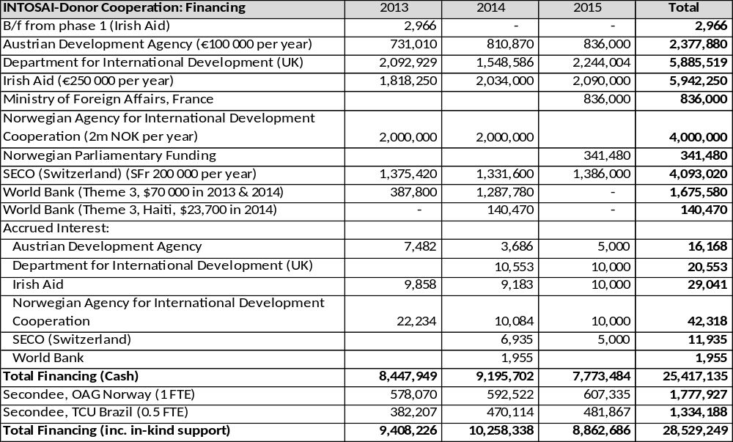
All figures in Norwegian Kroner
The Secretariat has been informed that there is some uncertainty regarding the funding from DFID for 2015, around 2,2 million NOK, due to an expenditure review in the UK. The Secretariat has put in place contingency plans so that if this funding does not materialise, the shortfall would be met through:
- Increasing the proportion of the Norwegian Parliamentary funding allocated to the INTOSAI-Donor Secretariat, by 1,7 million NOK
- Utilising the revised contingency of 300 000 NOK
- Making savings of 200 000 NOK from staff and program expenditure.

Budget Execution, 2013
The following table shows actual expenditure against the PD budget for 2013. As noted above, at the start of 2013, the Secretariat faced a 31% financing gap compared to the approved budget. This gap increased when NORAD confirmed its commitment would be 2 million NOK per year rather than the 2.5 million NOK hoped for. At the same time, the Secretariat was in discussions with SECO and DFID which looked promising but by the summer no grants has been signed. IDI was left facing a potentially large deficit on the work of the Secretariat. In the summer, IDI had to take a decision to cut all non-essential expenditure of the Secretariat and scale back delivery of planned program activities, to minimise the potential deficit. In September, IDI learned that the expected grant from SECO had been recalled, and the Secretariat was left with no available funding and the prospect of not being able to pay staff salaries. Some further planned activities were cancelled. In October, an agreement with DFID was signed, but the actual grant did not arrive in IDI’s bank account until 2 January 2014. At the end of October, the agreement with SECO was finally signed, and the funds arrived 11 December 2013. During October and November, all activities and staff salaries of the Secretariat were paid for from core IDI funds. Fortunately, Irish Aid then disbursed its planned 2014 funding in late November, enabling the Secretariat and IDI to pay salaries at the year end.
In light of the above events, for most of the second half of the year the financial aim of the Secretariat was to minimise program expenditure, leading to the largest possible underspend against the original budget. With major contracts not signed until October and cash not received until mid-December, there was no possibility of making up this underspend.
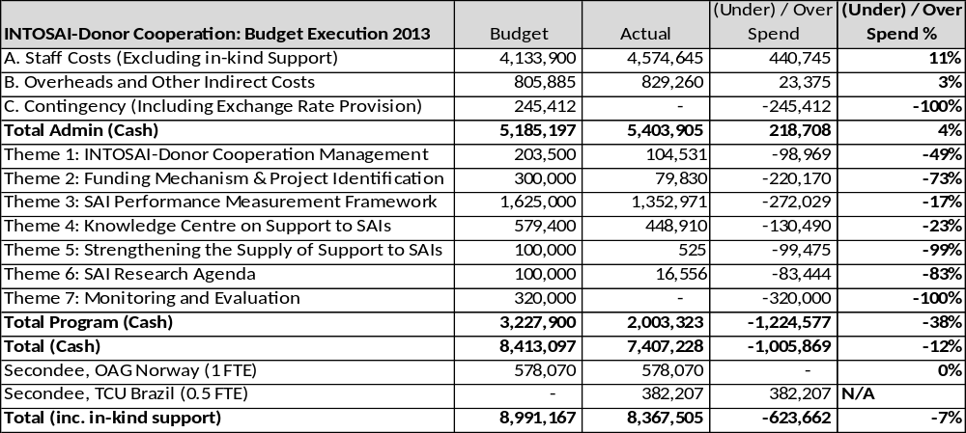All figures in Norwegian Kroner
Explanation for variances:
- A. Staff costs: 11% overspend is mainly from two sources. First, basic staff salaries were higher than budgeted following changes to Norwegian public sector pay scales from May 2013. Second, the Secretariat incurred higher staff costs in the form of overtime and travel time as Secretariat staff performed most of the field missions (particularly eight SAI PMF training events) in order to save funds, rather than using consultants to do this.
- B. Overheads and other indirect costs: IDI wide IT costs slightly higher than original budget estimate.
- C. Contingency: this is included to provide a buffer against unfavourable exchange rate movements and unexpected program costs. No expenditure is incurred against it, and it is gradually released into program activities as the need for a contingency reduced during the life of the program.
- Theme 1: the Secretariat cut staff participation in a number of events in the second half of 2013 due to the above funding pressures.
- Theme 2: the budget including costs of translating concept notes received under the global call for proposals. However, the timeline agreed for the global call, during 2013, meant that concept notes would only be received in January 2014, hence this part of the budget was not used during 2013.
- Theme 3: the delivery model for SAI PMF training has been different to that assumed in the budget. On the one hand, the budget assumed consultants would be used to help deliver the courses, where as instead SAIs and donors have provided in-kind staff support to help deliver training, saving considerable funds. On the other hand, to encourage participation in SAI PMF events among SAIs in the least developed countries, the Secretariat has found it necessary to provide financial support to one participant from each SAI that applies for such funding. Overall, there has still been a significant underspend on SAI PMF.
- Theme 4: the main budgeted costs here were for training SAIs on writing funding applications, where three courses were run as planned prior to the 2013 Global Call for Proposals, but a course in EUROSAI was cancelled due to limited registrations. Also, the costs for developing and delivering training for donors on working with SAIs, where the course was developed, with assistance from the UK NAO, but the planned delivery of the first pilot course, for USAID in Egypt, was unfortunately cancelled due to the worsening security situation in late 2013. The first pilot was instead delivered in Washington in March 2014.
- Theme 5: the budget was for running events for the supply-side community of practice, but following decisions at the 6th SC meeting in Beijing, the SC decided not to establish such a community at this stage due to the resource implications, but to revisit the issue based on a new paper from the Secretariat at the 7th SC meeting in 2014.
- Theme 6: a budget was included to contract out work on a paper on SAI funding levels. Due to financial pressures, it was decided to do this in-house, by including the relevant questions in the 2013 IDI Global Survey, with the analysis and report to be completed in the first half of 2014.
- Theme 7: the budget for contracting out work on a synthesis of findings from SAI project evaluations was included in the 2013 figures, though the activity was not included in the 2013 work plan (but is in the 2014 work plan). Also, the budget included costs for translating responses to the 2013 IDI Global Survey, which was sent out in late 2013 and hence the costs were incurred in 2014.

Income and Expenditure per Donor, 2013
The following table summarised the funds received and spent, by source, for 2013. In addition to the cash underspend versus budget of 1.005 million NOK, the total funds received (including accrued interest) exceeded the budget by 35,000 NOK. This leaves a balance of 1.04 million NOK carried forward to 2013. This carry forward has been split equally between SECO and Irish Aid.
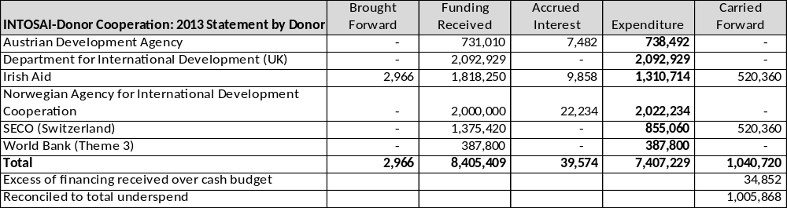
All figures in Norwegian Kroner
IDI’s financial statements have been audited and an unqualified audit opinion was given. This confirms the Secretariat’s actual expenditure as 7,407,228 NOK as per section 3.3 above, as well as the income and expenditure per donor, as shown in the table above.
The approved financial statement of IDI, with particular notes related to the Secretariat, is included as Annex B and Annex C. The contributions to and expenditures of the Secretariat were audited as part of the overall audit of the IDI. The original and signed audit report in Norwegian is included as Annex D and the audit report in English is included as Annex E.

Estimate of Available Financing per Year, 2013-15
Based on the balance carried forward, and the revised estimates of available funding for the remaining period, compared to the original budget, there is additional funding available for reallocation. In addition, the required contingency reduces as the risks from exchange rate fluctuations reduce each time foreign currency is received. However, some activities delayed from 2014 need to be budgeted for in 2014. The following table estimates the available financing per year.
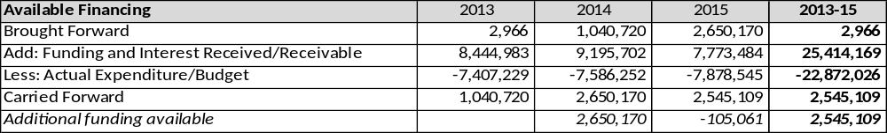
All figures in Norwegian Kroner

Proposed Revised Budget, 2013-15
As the Cooperation moves into the second half of phase two, it seems an appropriate time to consider a revision to the approved budget. The following sections explain the reasons for such a budget amendment.
Projected Changes to Staff numbers (including Secondee from OAG Norway)
 | 2013 | 2014 | 2015 | 2013-15 Average
Program Document (Technical staff) | 4,5 | 4,5 | 4,5 | 4,5
Actual (Technical) | 4,5 | 3,5 | 4,75 | 4,25
Actual (Coordinator) | 0 | 1 | 1 | 0,67
Actual (Total) | 4,5 | 4,5 | 5,75 | 4,92
Support from SAI Brazil, in the form of 0,5 FTE during 2013-15 to support SAI PMF implementation in OLACEFS is excluded from this table, due to the specific earmarking of this support.
Overall, the table shows that the Secretariat is operating with fewer technical staff than planned during phase 2 (2013-15). This reflects vacancies throughout 2014 resulting from various staff movements, partially offset by an increase in 2015 as all vacancies are gradually filled and the position of Head of Secretariat becomes a full time position. The Secretariat has also hired a coordinator to provide logical assistance with the administration of training courses, the Database etc. from January 2014. This has partially helped the Secretariat to manage with reduced staffing during 2014. Including the coordinator, the Secretariat staffing averages at 4,92 FTEs for the period, against the original plan of 4,5 FTEs.
Explanations for changes in FTEs
- Technical staff (2014): Einar made head of IDI (0,5 FTE reduction), Silje on maternity leave (0,75 FTE reduction), Meike on medical leave (0,08 FTE reduction), with temporary replacement in place from September (add 0,33 FTE). It was not possible to fill these vacancies until it was confirmed that the new Head of the Secretariat was an internal candidate.
- Coordinator: added from January 2014 onwards. Secretariat staff were spending too much time on logistics for events (e.g. 8 SAI PMF training courses in 2013, 3 courses on application writing, Steering Committee meetings etc.). Having a coordinator frees up time for the technical staff, helping to deal with the reduction in number of technical staff.
- Technical staff (2015): head of Secretariat full time rather than half time (add 0,5 FTE), one advisor not replaced with cover during first quarter (0,25 FTE gone)
It should be noted that all staff, except the Head of the Secretariat, are now employed on temporary contracts ending 31 December 2015. Staff are legally contracted by the IDI, and IDI takes on the legal responsibility and any long term costs related to these staff, not the funding donors.
Revised Estimates of Staff Costs
Overall, there was an overspend on staffing in 2013 of around 440 000 NOK. Similarly, the budget for 2014 is requested to be increased by around 430 000 NOK (so that 2014 budget is around 2% above 2013 actual expenditure). The increase comes from two main sources:
- National insurance costs: the original budget calculated national insurance only on basic salary. In practice, national insurance is payable on all staff costs, including housing allowance, childcare, pension, travel time and overtime. The budget was under estimated by 155 000 NOK.
- Overtime and travel time costs: 2013 budget of only 120 000 NOK. Based on 2013 actual costs this has been increased to 375 000 NOK, giving an extra 255 000 NOK. A key driver of these costs are the SAI PMF training courses, which have largely been delivered by Secretariat staff (charged to admin) rather than consultants, as forecast in the budget (charged to program). This is further evidence below.
In addition, the budget forecast for the remaining period is based on current salary rates and expected average increase during 2015, rather than 2012 salary rates and assumed inflationary increases (as used for the original budget).

Switch from Use of Consultancy to Staff for Technical Delivery
The original budget foresaw moderate use of consultancy for delivery of technical work, as follows:
Theme | Activity | Budget | Budget | Budget
 |  | 2013 | 2014 | 2015
2 | Global Call Reviews | 100 000 | 100 000 | 100 000
3 | SAI PMF Training* | 340 000 | 170 750 | 171 519
3 | SAI PMF QA Reviews | 100 000 | 100 000 | 100 000
4 | Donor Training | 80 000 | 25 000 | 25 000
4 | Training on Applications* | 172 500 | 173 063 | 173 639
7 | Synthesis of Evaluations | 140 000
7 | Evaluation of IDC* |  | 500 000 | 500 000
 | TOTAL | 932 500 | 1 068 813 | 1 070 158
* Including travel, accommodation etc.
All figures in NOK
Actual use of consultancy in 2013, and revised budget for 2014-15, is less than forecast, as follows:
Theme | Activity | Actual | Budget | Budget
 |  | 2013 | 2014 | 2015
2 | Global Call Reviews |  | 52 686
3 | SAI PMF Training* | 139 736
3 | SAI PMF QA Reviews |  | 75 000 | 50 000
4 | Donor Training | 117 159 | 74 183
4 | Training on Applications* | 224 680 |  | 120 000
7 | Synthesis of Evaluations |  | 125 000
7 | Evaluation of IDC* |  | 500 000 | 500 000
 | TOTAL | 481 575 | 826 869 | 670 000
All figures in NOK
In total, the Secretariat spent 450 000 NOK less than expected on consultants during 2013, and plans to spend around 240 000 NOK less in 2014 and 400 000 less in 2015. There are a number of reasons for this:
- Issuing the global call for proposals every second year reduces costs for both Global Call Reviews and Training on Application writing.
- The timing of the global call means that the next set of reviews are likely to fall in January 2016, beyond the current phase of the program.
- The Secretariat received in-kind support for Global Call reviews from SAI Norway and SAI Sweden in early 2014, which will not be reflected in IDI’s Financial Statements, but did reduce the need for consultancy in this area.
- The delivery mechanism for SAI PMF training has shifted from having one consultant trainer on each course, to delivery by Secretariat staff, other IDI staff, and in-kind support from the SAI and Donor Community.
- During the second half of 2013 the Secretariat faced an acute financial crisis and was limited in its ability to hire consultants, so had no choice but to use staff for delivery of programs where possible.
In fact, over eight SAI PMF courses in 2013 and nine in 2014, consultants were used only twice: once to assist the Secretariat to design and update the initial SAI PMF training material; and once as emergency cover due to staff illness.
Apportionment of Support Staff Costs and Overheads
From January 2014, the IDI Board has decided to modernise IDI’s accounting and budgeting system, to move towards ‘departmental budgeting’, so that the costs of each department more accurately reflect the costs of delivery of programs of that department. The departments are: Dept 1, admin; Dept 2, IDI Programs; Dept 3, INTOSAI-Donor Secretariat. The main implications are that full staff costs are allocated direct to the relevant department, and support staff costs, indirect costs and overheads are apportioned between departments according to an appropriate cost driver. Further, the calculation of basis for apportionment has been updated. A similar system has been applied to the INTOSAI-Donor Secretariat since its establishment, so it mainly impacts on the IDI programs. However, there are some minor differences in the updated system, as shown below.
 | Old System (2010-13) | New System (2014-15)
Basis for apportionment of:  - support staff costs  - IT costs (telecomputing, webserver) | Proportion of INTOSAI-Donor Secretariat staff to IDI program staff | Proportion of INTOSAI-Donor Secretariat staff to IDI program staff
% of support staff costs and IT costs (telecomputing, webserver) apportioned to the INTOSAI-Donor Secretariat | 21% | 19%
Basis for apportionment of:  - Pension costs  - Oslo Rent  - Oslo Operating costs | Proportion of Oslo based INTOSAI-Donor Secretariat staff to Oslo based IDI program staff | Proportion of Oslo based INTOSAI-Donor Secretariat staff to Oslo based IDI program staff
% of pension, rent and operating costs apportioned to the INTOSAI-Donor Secretariat | 31% | 23%
Basis for apportionment of other miscellaneous overheads, e.g.:  - Insurance costs  - Auditors fee  - IT hardware  - Non-allocable translation costs (e.g. IDI Focus newsletter)  - Telephone and mobile costs  - IDI staff meeting costs  - IDI board meetings  - IDI bank charges | Not previously apportioned to the INTOSAI-Donor Secretariat | Proportion of INTOSAI-Donor Secretariat staff to IDI program staff
% of above apportioned to the INTOSAI-Donor Secretariat | 21% | 19%
While the proportion of support staff costs allocated to the Secretariat has fallen, the total number and costs of support staff has increased by 0,5 FTE, due to changes in IDI structures. Specifically, the administration department is now headed by a Deputy Director General (this was previously a 0,5 FTE position, combined role with the Head of the Secretariat). However, these additional costs have yielded other savings from better administration, such as a large reduction in IT costs.
The following budget has been prepared to account for all the above issues. This shows the original and revised budget for each year, and the total. A contingency is included for exchange rate fluctuations.
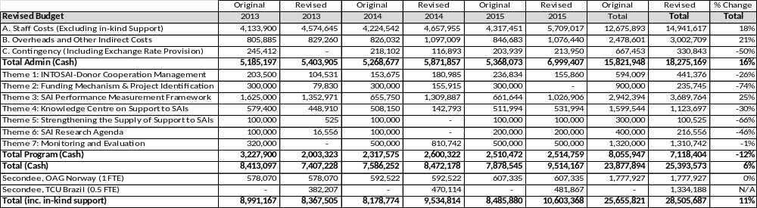All figures in Norwegian Kroner
It should also be noted that the above budget reconciles with the request for budget reallocation letter submitted to the Austrian Development Agency (19 June 2014), and the IDI budget for 2015, as approved by the IDI Board (3 November 2014).
This budget lies within the expected funding of the Cooperation, as demonstrated by the revised financing schedule shown below. On this basis, it is expected that most of the 2013 underspend will be carried forward for use in 2015. This is largely due to the high staff vacancy levels that will characterise most of 2014, and the difficulty in filling these vacancies promptly with appropriately experienced staff.
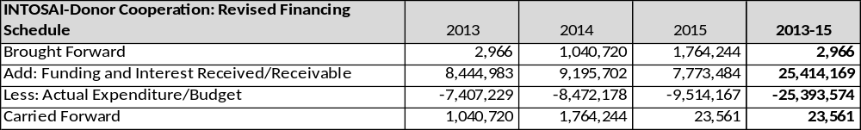All figures in Norwegian Kroner

Future Matters Under Consideration to Improve IDI Financial Management and Reporting
Program Budgeting
In the current program document, all staff costs are shown against administration. However, the activities of the Secretariat’s technical staff are largely programmatic in nature, relating to the seven themes of the Cooperation. Use of program budgeting, in which staff costs are charged to the seven themes in proportion to time spent on each theme, would give a better picture of the actual costs of the Secretariat’s activities.
IDI’s current management accounting system does not support such an approach. However, IDI has begun examining possible electronic time recording systems which could provide an interface between staff time records, the payroll system, and the programmatic structure in IDI’s accounting system. Decisions on adoption and the specific nature of the system will be made in 2015, potentially enabling full program budgeting and reporting from 2016 onwards.
Financial Reporting
Financial information on the Secretariat’s expenditure is included in note 10 to IDI’s Financial Statements. This follows the minimum reporting requirement under Norwegian Foundation law. However, the basis for reporting is on administrative classification (type of expenditure), making no distinction between administration and program expenditure, or the seven themes of the Cooperation. To enable easier reconciliation between IDI’s financial statements and reporting against the budget in program document, it is planned to include an additional note in the accounts, using the following format, from the 2014 accounts onwards. This would also ensure that the classification of expenditure according to administration, program and the seven themes was subject to independent external audit.
Expenditure Type and Project Code | Payroll and Related Costs (Class 5) | Travel and Accommodation Costs (71) | Other Operating Expenses  (Other) | Total
Administration
- Staff Costs (80000) | XX | - | - | XX
- Overheads and other indirect costs (80000) | - | - | XX | XX
Admin Total | XX | XX | XX | XX
Program
Program staff costs (81000) | XX | XX | XX | XX
Theme 1 (81100) | XX | XX | XX | XX
Theme 2 (81200) | XX | XX | XX | XX
Theme 3 (81300) | XX | XX | XX | XX
Theme 4 (81400) | XX | XX | XX | XX
Theme 5 (81500) | XX | XX | XX | XX
Theme 6 (81600) | XX | XX | XX | XX
Theme 7 (81700) | XX | XX | XX | XX
Program Total | XX | XX | XX | XX
TOTAL | XX | XX | XX | XX

EXPLANATION OF MAJOR DEVIATIONS

While there are no major deviations from the 2013-15 work program to date, the following minor deviations are noted:
- SAI Supply side community of practice not established as planned, followed decision of the SC at the 6th SC meeting in Beijing, October 2013.
- Frequency of Global Call for Proposals changed from annual to every two years, by decision at 6th SC meeting.
- Pilot of the training for donors on working with SAIs planned for Egypt in late 2013 cancelled due to worsening security situation there. First pilot subsequently held in March 2014 in Washington.
- Update of the 2010 stock taking and benchmarking of SAI funding levels both incorporated into the 2013 IDI Global Survey, launched in late 2013, report expected by the end of 2014.

MANAGEMENT OF INTERNAL AND EXTERNAL RISKS
The following are extracts from the INTOSAI-Donor Cooperation Risk Register (I.e. internal risks) contained in the PD, focusing on the areas currently perceived to have the greatest residual risk. Four key risks from the PD are still perceived to be risks, while one new risk has been identified, which appears critical. Proposed risk responses, residual risks and risk owners are identified below.
Key Risks to Programme Success & Sustainability |  | Risk Response | Residual Risk | Risk Owner
Resourcing
Secretariat has insufficient staff and financial resources to implement activities of the cooperation. |  | Sufficient financial and in-kind support now secured. Current challenge relates to vacancies in the Secretariat following turnover and moves in 2014. Recruitments in progress. Until vacancies filled, focus on high priority activities and utilising support from others. | Unable to recruit sufficiently experienced staff in timely manner. | IDI (INTOSAI-Donor Secretariat)
Theme 3
New Risk | Donors and SAI providers impose SAI PMF assessments on developing country SAIs, reducing ownership of the SAI PMF and leading it to be regarded as a donor tool, reducing its eventual use. | Continually raise the issue on SAI PMF training, at SC meetings and with donors and SAI providers in other for a. | Some donors and SC members continue to misuse SAI PMF, potentially damaging its reputation as an INTOSAI owned product. | IDI (INTOSAI-Donor Secretariat) and SC members
Theme 4
SC donors and SAI providers of support design and implement SAI capacity development projects which do not reflect the MoU principles and INTOSAI priorities. |  | Communication and advocacy on the MoU principles, training and awareness raising for donors and SAI providers, support to strengthening capacity of SAIs to engage with donors and providers. Evaluation of INTOSAI-Donor Cooperation will also look at whether INTOSAI and Donor communities are following MoU principles. | Entrenched behaviour of SC donors and SAI providers does not change. | IDI (INTOSAI-Donor Secretariat) and SC members
Theme 5
No consensus within the SC on the need to scale up and strengthen providers of support to SAIs. |  | Discussions at 6th SC meeting demonstrated lack of consensus in this area.  Look for simple and effective ways to minimise the biggest risks from weaknesses in the provision of support to SAIs. | Continuing weaknesses in the supply of support undermines its effectiveness. | IDI (INTOSAI-Donor Secretariat) and INTOSAI CBC
Theme 7
Donors and SAIs do not provide access to SAI project evaluation reports, or help facilitate country level studies for an impact assessment of the Cooperation. |  | Advocate on the importance of evaluations for lesson learning, and guarantee anonymity of country level findings if required. | Evaluation findings may be skewed to those donors and SAIs that chose to engage, rather than being a fair representation of the population. | IDI (INTOSAI-Donor Secretariat) and SC members

The critical assumptions for the INTOSAI-Donor Cooperation (I.e. external risks) identified in section 8.1 of the PD remain unchanged. In summary, these critical assumptions imply that for the INTOSAI-Donor Cooperation to deliver the intended impact, the INTOSAI and Donor communities must also:
- Support other initiatives promoting accountability and transparency in public finances, implementation of SAI recommendations, and effective legislative bodies.
- Ensure all initiatives follow the principles of country ownership and relevance to the needs of SAIs.
- Ensure effective communication, dissemination and outreach of the Cooperation’s activities to all SAIs and all stakeholders engaged in supporting SAIs in developing countries.

PROPOSED ADJUSTMENTS TO AGREED PLANS
The donors are asked to approve the proposed revised budget, as set out in section 3.6 above.
The donors are asked to agree to the change to the 2014 milestone for output indicator 2.2 (from 1 to 0), reflecting the SC decision not to launch a global call for proposals in 2014.

Three year moving average, based on analysis from the SAI Capacity Development Database
And other relevant grant agreements – see section 1.4
‘Evaluation of Public Financial Management Reform in Burkina Faso, Ghana and Malawi 2001-10, Final Synthesis Report’, Andrew Lawson, April 2012
Milestone dates for outputs are annual, the first milestone date being 31 December 2013. Milestone dates for initial outcomes and high-level outcomes are every second year, the first being 31 December 2014. However, interim progress towards these milestones (as at 31 December 2013) is included where possible.
Accountable Grant Arrangement for International Capacity Building for Supreme Audit Institutions, which also provides support to the INTOSAI Capacity Building Committee through the IDI
The contractual agreements between IDI and DFID are therefore determined by the existing grant agreement which may differ from the Program Contract signed with the other donors. To resolve this, a new Annex 6 was added to the PD, to include extracts from the Program Contract, in order to align Planning, Budgeting, Reporting and Evaluation requirements.
ADA (Austria) sent their apologies, while SECO (Switzerland) did not sign the Program Contract Addendum until 31 October 2013.
During 2013, 21% of IDI’s support staff costs and IT costs were charged to the Secretariat, reflecting the ratio of Secretariat staff to IDI program staff. Also, 31% of IDI’s pension costs, Oslo rent and Oslo operating costs were charged to the Secretariat, reflecting the ratio of Oslo based Secretariat staff to Oslo based IDI program staff.
For a more detailed investigation, see the INTOSAI-Donor Secretariat: Narrative Progress Report 2012 and Final Report 2010-12, where analysis of repeat PEFA assessments shows a significant net increase in scores on PEFA PI-26.
Note that these baseline figures have been updated, as analysis of the 2013 Global Survey data and comparison to 2010 revealed that the original 2010 baseline figures were calculated by including those SAIs that answered ‘other’ in the denominator. As ‘other’ is ambiguous – and could indicate that no legal time frame exists – it is thought better to exclude ‘other’ from the calculation.
The Secretariat uses its core funds for global and regional initiatives as per the agreed work plans. At the request of a donor group in Haiti, the Secretariat agreed to coordinate the delivery of a country level SAI PMF training course in Haiti, delivered on a cost recovery basis. The Secretariat used external trained SAI PMF trainers to deliver the course, rather than Secretariat staff.
Only Oslo based staff are eligible to join the Norwegian pension scheme. Regional employees must make their own pension arrangements.
The INTOSAI-Donor Cooperation budget is shown as department 3 within the overall IDI budget.

